**. -c,oWNc0**

-,;,

###### T OWN COUN CIL M EETING Item 5

* ♦

**2** .._ **b**

***o,.,,,,,v, "'***

###### Business & Regeneration Report - 27 November 2019

|  |  |
| --- | --- |
| **Town Trading** | Reports from traders is that business is doing well and they are gearing up to the festive season. Some have expressed concerns over the impact of 'Brexit' and now the General Election is affecting consumer confidence.  I continue to introduce myself to businesses, most recently the newly opened Inside Wellness centre (1&2 Griffiths Square).  Indoor Market: The Craft Shack has moved to a larger unit with a window frontage and they have reported a positive increase in footfall as a result. Work continues on the fitting out of the two new units for CJ's Butchers with a view to opening at the end of November. 'Poochie Pampers Dog Grooming' has also opened. As a result, the Indoor market is now fully occupied.  Lot 11 Cafe has now expanded into the former 'Step in' shoe repair on the high street. Following press reports of a review of Boots stores nationally, I've spoken to the Manager of the High street (19/21) branch and she confirmed that both branches in Mold are very busy and the pharmacists would be trained to issue NHS prescriptions under the minor elements programme.  The 'EE connected' Store confirmed the temporary closure in Mold was due to a staffing shortage and they had now recruited a new Manager. Following a period of training they hope the store will be back open before Christmas as this is a very busy store for them.  Dolphin Inn are looking to submit a revised planning proposal in the near future following feedbackon their initial consultation.  The agent for the Ambrose Lloyd Centre have confirmed that they are in discussions  with an interested party.  The previous 'Alison's Pot Pourri Florist' on Wrexham street is due to have new tenants by the end of the month.  I have been to see the new manager of the B&M store and raised concerns over the  condition of the fac;:ade, and received agreement to send a letter to their Head Office. |
| **Environment** | Following report s and complaints of smells in the High Street, the drains have been inspected. The drains had a full draining and cleanse two months ago. This situation will be monitored by the Streetscene Area Co-ordinat or should any further complaints be received.  The Str eetscene Area Co-ordinat or also had a meeting with the contractor who carried out the works in the bus station. This has highlight ed some of the unresolved items which will now be followed up.  The Town cleaners now report directly back to the Streetscene Area Co-ordinator which will provide additional control on environmental issues in the Town. |
| **Projects** | Mold Business Impro vement District (BID): A meeting was held in the Daniel Owen Centre on the 11th No vember by the consult ant s (Mosaic Partnership) as part of the ongoing consultation. Mosaic are seeking to est abli sh a business task group to lead  this process and the proposed BID boundary is currently being reviev.,ed. Mos i<:_ |

|  |  |
| --- | --- |
|  | will be undertaking further consultation with individual businesses ahead of producing a 'summary business plan' with a ballot scheduled for end of February/March 2020.  We have commissioned a promotional video of Mold featuring this year's festive events which will then be used to promote future years' events.  **Christmas light switch on** - 26th November 2019 **Special Christmas Market** - Sunday pt December 2019 **Santa Dash** - Sunday 8th December 2019  **Santa Float** Evenings from 1st December.  Ahead of Sma ll business Saturday on the 7th December, we are working with Camrayard photography who have provided a free photoshoot prize draw for product marketing images. Entry will be available for all M old small businesses and the winner will be drawn at the special Christmas market on the 1st December.  A meeting is scheduled with the Town Clerk and the head of Streetscene regard the public conveniences.  FCC confirmed they will be providing a reduced price business parking permit in town for £48 (Love Lane car park) - awaiting details of the application process. In addit ion, the notices in the Town car park have caused some confusion, I'm current ly seeking clarification from FCC.  Collated the business training needs from the business contact forms, working in partnership with FCC to put on a series of courses. |
| **Other** | We have been informed by the Great British High Street that this year's awards have been a success. As a General Election has been called, I'm disappoint ed to report that the awards have been postponed until the end of January.  I am very pleased to report that the judges visit om Mold had great coverage in the Clerks & Councils Direct. |

**MERCER**

**MAKE TOMORROW, TODAY**

# Mold TC (36)

**CLWYD PENSION FUND**

31 MARCH 2019 ACTUARIAL VALUATION RESULTS

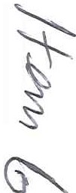

##### 2019 ACTUARIAL VALUATION SUMMARY CLWYD PENSION FUND - Mold TC (36)



VALUATION BALANCE SHEET SUPPORTING INFORMATION

|  |  |
| --- | --- |
| **,.,,.". \T** - ,.... ... .. | |
| Emp loye r Type | Scheme Employer |
| Open/Cl osed | Open |
| Ill Health Captive | Yes |
| Funding Basis | Ongoing |



£16,850 104.3%

TERMINATION POSITION

.

- (£ 224,700)

EMPLOYER FUTURE SERVICE COST

|  |  |  |
| --- | --- | --- |
| Guarantor in Fund I | n/a |  |
| Deficit Contribution Prepayment Selected | I | None |
| Implied Recovery Period from 1 April 2020 | I | 9 years |

**M MERCER**

M AKE TOMOR RO W, TO DAY



17.8%

EMPLOYER CONTRIBUTION REQUIREMENTS

|  |  |
| --- | --- |
| *r.. ...*.*..*  **'McCloud Est i ma t ed Costs** I  I ***J*** ' | |
| Increase in Liabilities (% of liabilities) | 0.9% |
| Increase in Liabilities | £3,520 |
| Increase in Future Service Rate (% of pay) | 0.7% |

|  |  |  |
| --- | --- | --- |
| ntributions : | Futu re Service Rate | Surplus / Deficit  Contributions |
| **2020 /21** | 17.8% | (£2,200) |
| **2021/22** | 17.8% | (£2,300) |
| **2022/23** | 17.8% | (£2,400) |

C;

*The figures above exclude the potential impact of the Mccloud judgment. Further information of the impact* is *shown on the next page. The figures above include an allowance for short term pay of* 2% *p.a. for the four years to 2023124.*

*This schedule should be read in conjunction with the letter issued by Clwyd Pension Fund, the Funding Strategy Statement 2019 and any associated correspondence regarding the Actuarial Valuation* as *at 31 March 2019. The contributions will be* reassessed as *part of the 2022 Actuarial Valuation and new contributions will be payable from 1 April 2023.*

*Whilst reasonableness checks on the data provided by the Fund have been carried out, they do not guarantee the completeness or the accuracy of the data. Consequently, we do not accept any liability in respect of our advice where we have relied on data which is incomplete or inaccurate.*

**t"** -- **INVESTORS**

' **EOPLE**

**V.flfeor Um.':.edis authorlud:iofld r• ;ul :1tDd *lrJ* th o Fln:lncillCor,d;ictAl.l:hcwty**

**Ro!1:lotodinEr,gbrld No.984275Rogi::.lor• O!f : 1 T_, "'-W t.To,,;or PIDeo, london EC3R seu**

.. M ARSH & Mc LENN AN

**lll(;'P'Jill** CO MP ANIES

##### 2019 ACTUARIAL VALUATION CONTRIBUTION PROJECTIONS CLWYD PENSION FUND - Mold TC (36)

**M MERCER**

M A KE T O M O RRO W, TO D AY

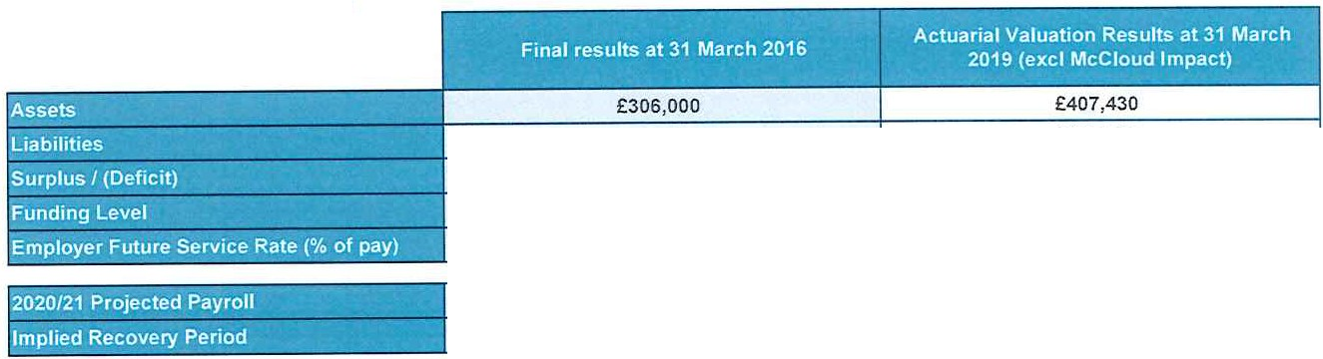

**DETAILED RESULTS**

£327,000 (£21,000) 93.6%

17.4%

£390 ,580

£16,850 104.3%

17.8%

£97,430

12 yea rs

£97,430

9 years

l O,!s 20 i=uture Se N ice Am' o nt ·- .

-- "- - ... **-4.**

_[?efic!

0j 9E,O

17.4% £16,620 17.4% £16,620

£1,860 £1,860 :· Mc Clo ud Es timated c o" st s - ,,

l_ e i:: v_e!}' _ mo_u ! . , **t** • ••• ..

|  |  |  |  |  |  |  |
| --- | --- | --- | --- | --- | --- | --- |
| 17.4% | | £16,950 | 17.8% | £17,300 | 18.5% | £18,030 |
| 17.4% | | £17,290 | 17.8% | £17,650 | 18.5% | £18,390 |
| 17.4% | | £17,640 | 17.8% | £18,000 | 18.5% | £18,750 |
|  |  | |  | |  | |
| £2,000 | | (£2,200) | | (£1,800) | |
| £2,100 | | (£2,300) | | (£1,900) | |
| £2,100 | | (£2,400) | | (£2,000) | |

2 Fut ure S erv ice• Anio nt

020 12·1

2021/22 Futur·e s ervice Amount

f utu_re j s _ r'!_ice Amount : *:*

20_, 3,

. . . '.

|  |  |  |  |
| --- | --- | --- | --- |
| **t O O**  ,...-- | **!** | **efic_i ec ery Am o un**.**t**  -·. - .. · .. - .. | |
|  |
| **2021 /22 Deficit Recovery Amo nt** | | | |
| **2022i23 Def ic it Re oc very:** | | | **Am ount** |

.,-

- ,.

, " .. -•

|  |  |  |  |
| --- | --- | --- | --- |
|  | I I | | |
| n/a | n/a | n/a |
|  | n/a | n/a | n/a |
|  | n/a | n/a | n/a |

**u-- INVESTORS**

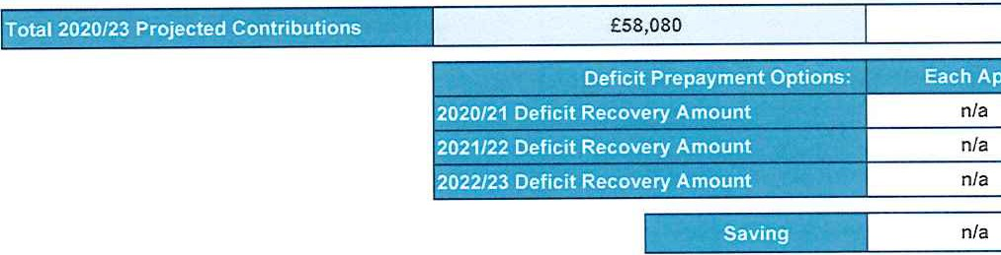

£46,050

£49,470

n/a

n/a

n/a

,!' **I PEOPLE**

**Ml,,wr l.lrrli'!od b 11Ll1h0rlsecl an d 1•Q\Jl.1tod by Ul• FINnebl Authority**

**Rogil.101odIn E L1rld No. 9e4Z75Regi'Sl.orod O t11eo: I TDWD• Pb c,.e Wu!, To- r Pbc., London EC3RSBU**

.. MARSH & MCLENN AN

**IIIV""""III'** C O MP A N IES

##### 2019 ACTUARIAL VALUATION FURTHER INFORMA TION CLWYD PENSION FUND - Mold TC (36)

ANALY SIS OF CHAN GE IN FUNDING POSITION (£000s)

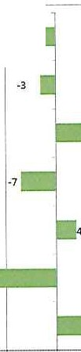

**Deficit.1t 31 March 2016 -21**

**Unwindin g of deficit interest**

**Inves tment re:turns vs 2016 assumptions**

62

**Chanee in actuarial assumptinos**

**Short te rm pay for 4 years at 2% p.a .**

**Membership changes andother factors**

**-18**

**Deficit at 31 March 201g**

17

I

**M MERCER**

M AK E T OM O R ROW. T OD AY

ANALYSIS OF CHANGE IN FUTURE SERVICE RATE

|  |  |
| --- | --- |
|  | 17.4% |
|  | +0.1%  -1.6% |
|  | +1.9% |
|  | 17.8% |

•



I

I

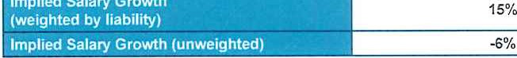•

|  |
| --- |
|  |
|  |
| 0% |
| 0% |
|  |

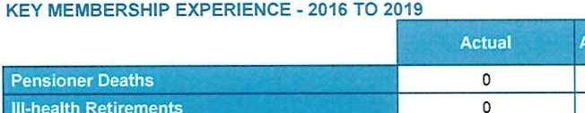

* 30 -20 -10

SU MM AR Y OF M EM BERSHI P DETA ILS

|  |  |  |
| --- | --- | --- |
| r• ·. ,· ·-. :,• • **T** . '" ..  .J - ,, . - ., " - - ~ -..!; ., .. -;,_ --, . *,:;* .. 31 March 2016 3_1) efarc h **2019 "·oil** | | |
| Number of Active members | 3 | 2 |
| Total Post 2014 Actual Salaries (£ p.a.) | 65,300 | 54,870 |
| Total Pre 2014 FTE Salaries (£ p.a.) | 79,970 | 54,870 |
| Total Pre 2014 FTE Salaries for those in both valuations(£ p.a.) | 79,970 | 75,380 |
| Total Liabilities (£) | 127,160 | 147,230 |
| Ave rage Age (weighted by CARE pay) | 49.8 | 48.2 |
| Average Employee Rate(% of pensionable pay) | 6.3% | 6.2% |
| Number of Deferred Pensioners | 2 | 1 |
| Total Liabilities (£) | 92,880 | 3,810 |
| Total Deferred Pensions at the Valuation Date(£ p.a.) | 3,910 | 180 |
| Number of Current Pensioners and Dependants | 3 | 5 |
| Total Liabilities (£) | 106,970 | 239,540 |
| Total Pensions Payable (£ p.a.) | 5,270 | 12,370 |

1 0 20 30 40 so 60

70I

***l ....;,,.* INVESTORS**

***'4.:._i!* IN PEOPLE**

**Mon:..r Umilotd is W! Oft:s.d tr.d r.;ul;l.clby tho f'""nei:11ConduttAutl'lori'ty**

**R t• rod in Er,gl:lndNo. 9$42 75 R !Ofodornc. : t Tov.orPlal:4t Wo I, Tow,;,t Pbc:o, Ll)ndorl EClRSBU**

.. MARSH& M c LEN N AN

**1111(--:-** COMPANIES

##### 2019 ACTUARIAL VALUATION EMPLOYER CONTRIBUTION PLAN CLWYD PENSION FUND - Mold TC (36)

**M MERCER**

M AKE T OM ORR O W. TO DAY

|  |  |  |
| --- | --- | --- |
| 2020 /21 | 17.8% | -£2,200 |
| 2021 /22 | 17.8% | -£2,300 |
| 2022/23 | 17.8% | -£2,400 |
| 2023/24 | 17.8% | -£2,400 |
| 2024/25 | 17.8% | -£2,500 |
| 2025/26 | 17.8% | -£2,600 |
| 2026/27 | 17.8% | -£2,700 |
| 2027/28 | 17.8% | -£2,800 |
| 2028/29 | 17.8% | -£2,900 |
| 2029 /30 |  |  |
| 2030/31 |  |  |
| 2031/32 |  |  |
| 2032/33 |  |  |
| 2033/34 |  |  |
| 2034/35 |  |  |
| 2035/36 |  |  |
| 2036/37 |  |  |
| 2037/38 |  |  |
| 2038/39 |  |  |
| 2039/40 |  |  |
| 2040/41 |  |  |
| 2041/42 |  |  |
| 2042/43 |  |  |
| 2043/44 |  |  |
| 2044/45 |  |  |
| 2045/46 |  |  |
| 2046/47 |  |  |
| 2047/48 |  |  |

*The figures above exclude the potential impact of the McCloud judgment.*

Please *note that the future service contributions are payable for* as *long* as *your organisation* has *active* members *in the Fund. In addition, employercontributions are subject to* a *minimum of zero. Your contributions will be* reassessed *as part of the next actuarial valuation.*

***r-...,.* I NV ESTORS**

*'!;,._,!* IN PEOPLE

**Merctor l lmltod b 11.1t11Grnod ond nogulotod by tho Flno r\Clal Conduct A!hloi l:y**

**R.;i l t, te d In En;b nd No. 9-a,4275Ro torod ornco:1 To- r PlacoWin t, Towr,r Pl11co, lorw:!Ofl ECJR 58U**

....**MARSH**&**M CLENN AN CO M PAN IES**

##### 2019 ACTUARIAL VALUATION NOTES CLWYD PENSION FUND - Mold TC (36)

**MMERCER**

**MA KE T OMOR RO W, TO DAY**

**Explanatory notes to accompany the 2019 Valuation Individual Employer Schedules**

The followingexplanatory information will be helpful to you when reviewing your organisation's preliminary 2019 actuarial valuation results schedule.

**Page 1** - **Employer Results Summary**

Th si summarises your headline valuation results and contributions that would be certified for your organisation in the 2019 valuation report. This includes your 2019 future service contribution

ra te (Primary Rate) and surplus/deficit contributions (Secondary Rate). It also sets out some of the key information about your organisation (e.g. type of employer, whether membership is open or closed to new members, whether you participate in the ill-health insurance arrangement, whether you have a guarantor, the costs on termination (where these are applicable), your recovery period, whether you have chosen to prepay contributions and the potential McCloud costs).

**Page 2** - **Contribution Projections**

This shows your organisation's funding position at both the current and previous actuarial valuation (or your starting contributions). The details provided are your organisation's own balance sheet information within the Fund, alongside the funding level (a ratio of your organisation's assets relative to your organisation's total liabilities assessed using the actuarial assumptions set outin the proposed Funding Strategy Statement (FSS)) for this valuation. A breakdown of the projected total£ contributions for 1 April 2020 to 31 March 2023 on both the existing funding plan and pro pose d 2 01 9 plan have been shown for comparison. A breakdown of the provision for potential McCloud costs (see FSS for further details) has also been show in the third column.

The£ future serviceco ntributions are estimates based on payroll in 2020/21, estimated from the latest contribution information, and is projected forward using the assumed increases in future pay progression, and allowing for any phasing/stepping in of changes in the % rate (if applicable to you). This is provided for budgeting purposes and you should therefore consider if the estimated payroll shown on the schedule is appropriate.

The £ de ficti co nt rib ut ions are the amounts required to recover the stated deficit (or run off the disclosed surplus) over the "implied recovery period" shown. From the year 2023/24 the deficit/surplus contributions would continue increase at 3.65% p.a. to the end of the recovery period (as shown in the page above if applicable).

**Contribution Options**

Depending on your circumstances and separate discussions, the following options may have been applied and this will be shown on your schedule: Reducing cash contributions in return for early payment (prepayments);

Phasing/stepping up changes in contributions (where total contributions are increasing);

Inclusion of a contribution provision for estimated McCloud costs to provide budget certainty for the 2020/23 contribution period. The alternative would be to make no provision but when the remedy for the McCloud case is known then additional contributions would be backdated and could be higher or lower than the estimated provision proposed.

**Page 3** - **Analysis of Change** in **Funding Position**

This page provides a reconciliation between the results emerging at the current and previous valuation. This section quantifies the impact on your organisation's surplus or deficit impact due to:

**Unwinding of deficit interest** - The unwinding of pension fund debt interest on the starting funding position.

1. ***,_.,***.. **INVESTORS**

***'4:i,.J* IN PEOP L E**

**"'1.weer Umllod I 11uthOIT.iodaridrogul,:.odby ti-.. Fln:;1nc:l11l Coc,c:lld>,uthomy**

**Reg rod Eng '"o. 98-427:!!i Roght01ocl or rio.: 1 To.,... Plxti W.:.t.To- rPl- , Londo!\ EC3R 58U**

.. M ARSH & M c LEN N AN

**llll( JII'** COMPANIES

##### 2019 ACTUARIAL VALUATION NOTES CLWYD PENSION FUND - Mold TC (36)

**MMERCER**

MAKE TOMORRO W, T ODA Y

Investment returns vs 2019 assumption - Actual investment gains or losses made compared to those expected within the assumptions adopted at the previous valuation.

Changes to actuaria l assumptions - The impact of the changes made to the actuarial assumptions adopted. This includes both financial and demographic assumptions. Further details of the changes made are detailed in the separate FSS.

**Short term pay** - The impact of allowing for lower short-term salary growth expectations which will have a positive effect on the funding position. This will be a minimum of 2% p.a. in line with the proposals in the FSS.

**Membership changes and other factors** - The net effect of general membership changes. contributions paid by your organisation, and pay and pension increases awarded. This can be significant for smaller employers with a small number of members. Experience over period gives more detail on salary growth and some membership changes:

* + **Salary Growth** - Actual salary growth observed for members at the valuation date in relation to pre-2014 pensionable service. Higher (lower) than the expected pay growth leads to a worsening (improvement) of the funding position.
  + **Leavers from pensionable employment and pensioner deaths** - shows the actual number compared to the number assumed by the Actuary - if these are

>100%, then the effect on the funding position is positive; if <100% then the impact is negative.

* + **Ill-health retirements** - Higher (lower) than expected numbers of ill-health retirements leads to a worsening (improvement)of the funding position.

Page 3 - Analys is of Change in Futu re Service Rate

This section provides a reconciliation between the future service rate emerging at the current and previous valuation. This section quantifies the impact on your organisation's rate of :

Change in profile of membership - This can be changes in age, gender and pay profiles for your organisation. This can be significant for smaller employers with a small number of members.

Change in actuarial assumptions - The impact of the changes made to the actuarial assumptions adopted. This includes both financial and demographic assumptions. Further details of the changes made are detailed in the separate FSS.

This page also shows a summary of the member data as at 31 March 2019 used in the valuation calculations. You should consider if this is a reasonable representation of your membership as this will affect the valuation calculations and contributions.

**Page 4** - **Employer Contribution Plan**

The full projection of expected deficiUsurplus recovery payments is set out in the table. Future service contributions are payable for as long as your organisation has active members in the Fund.

These contributions will be reviewed at least at each valuation with the next valuation currently planned to be in 2022 which will determine contributions from 1 April 2023 to 31 March 2026. In some circumstances your contribution rate may be reviewed prior to then.

**Clwyd Pension Fund October 2019**

***,:-6 -*'"' t INVESTORS**

***".. J* IN PEOPLE**

***11.oreet* umc.c1Is*•ub'lofr"M* and rai;ulll tod lh• Financial Conduct AuthClflry**

**R tarodIn Er,gbnd No. ie'-275Regb1a1od OOlee: 1 TOWDI Pl.le-Wut,Tiw,0r PlKo. lolldon EC3R 5BU**

.. MARSH & M CLENN A N CO M PA NIES

**MERCER**

**MAKE TOMORROW, TODA Y**

'•-!, INVESTORS

*"4.,._,!* IN PEOPLE **R ogblore d In En lot\d Ni,, 9&42;5 R, gl to1 o d omo.: , ToworPix.Wo t.To.,..rPbeo, London EC3R SSU**

Mercer Limited

No 4 St Paul's Square Old HallStreet Liverpool L3 9SJ



MARSH &M c LEN N AN COMPANIES



.. "