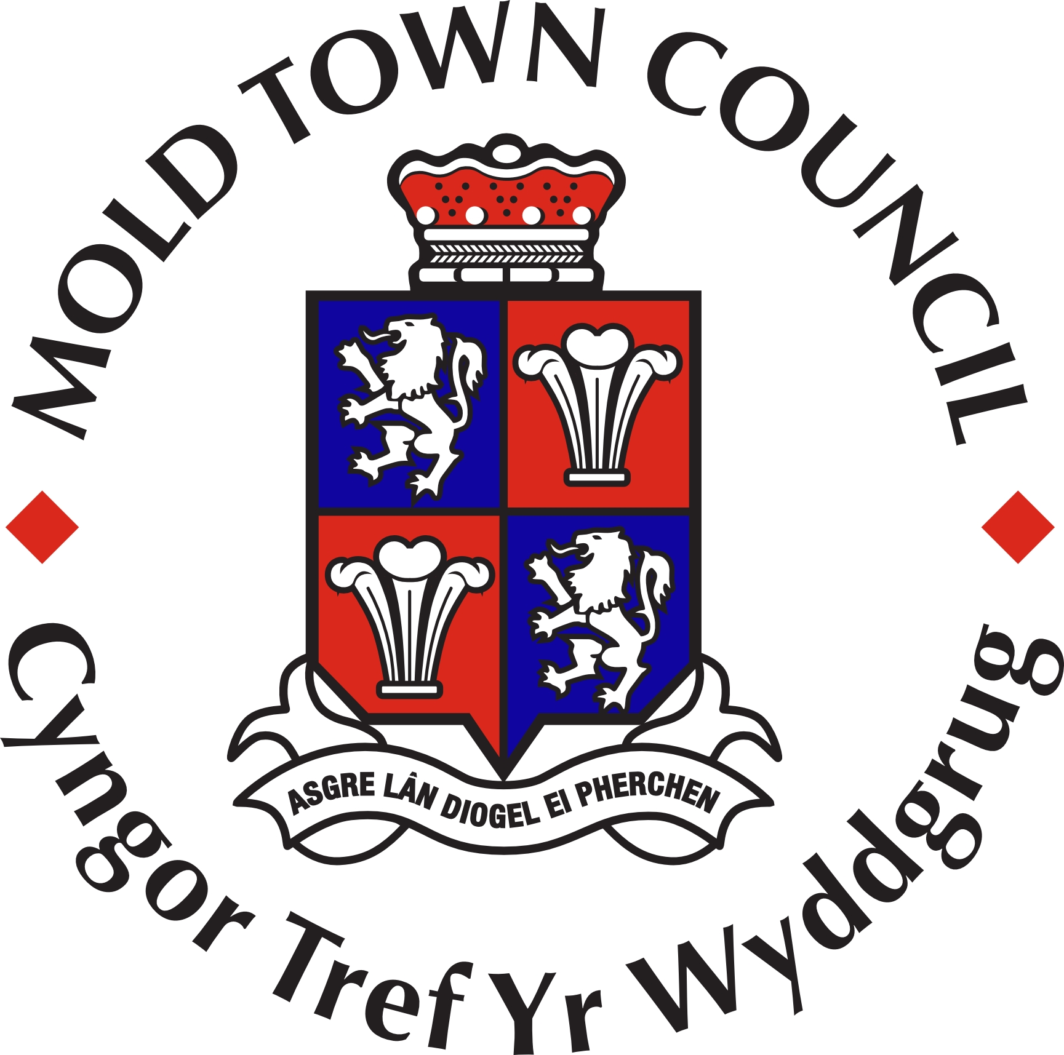

MOLD TOWN COUNCIL
Local Government (Wales) Measure 2011, Section 116
Notice of Co-Option
NOTICE IS HEREBY GIVEN that the Mold Town Council intends to Co-opt one member to fill the vacancy that exists in the office of Councillor for the West Ward of Mold Town Council.

Expressions of interest are being sought from members of the public who meet the following qualifications and are interested in representing their community on the aforementioned Town Council. You must be a British, Commonwealth, Irish or a European Union citizen and be 18 years of age or over; and meet at least one of the following criteria:
- registered as a local government elector for the area named above; or
- during the whole of the last 12 months occupied as owner or tenant land or other premises in the community named above; or
- your principal or only place of work during the last 12 months has been in the community named above; or
- you have during the whole of the last 12 months resided in the Commuinity or with 4.8 kilometres of it.

If you wish to be considered for co-option for the vacant seats or want more information regarding the role of a Town/Community Councillor please contact Samantha Roberts the Proper Officer, Clerk to the Council at Mold Town Council. Town Hall, Earl Road, Mold, CH7 1AB, Telephone: 01352 758532 by 9th July 2018.

Dated this 13th day of June 2018

Certain people are disqualified from standing, and these include paid officers of the community council, anyone subject to bankruptcy restriction orders and those subject to recent sentences of imprisonment.

