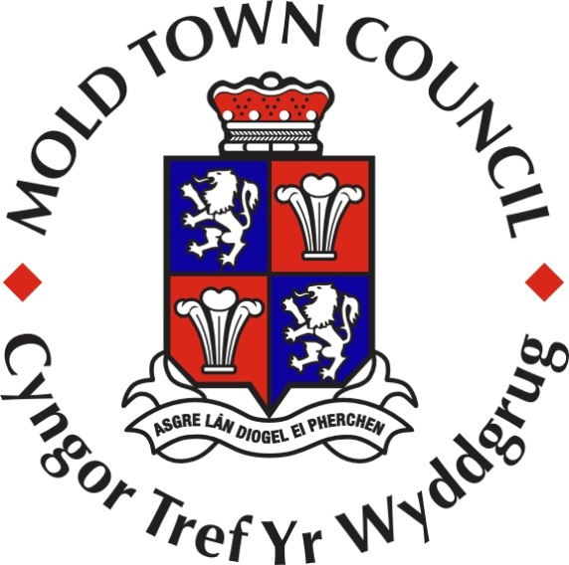

MOLD TOWN COUNCIL ANNUAL REPORT
MAY 2016 TO APRIL 2017
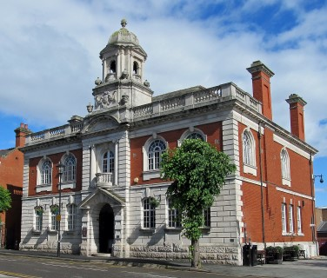
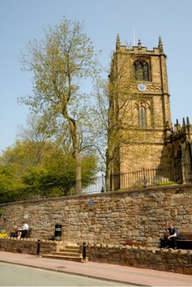
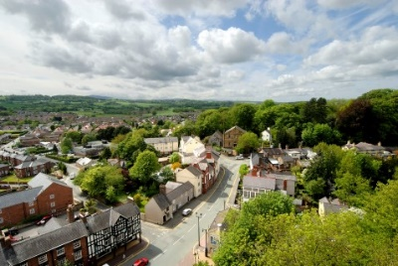
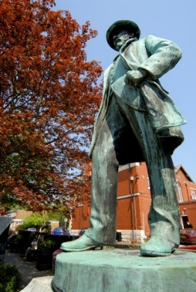
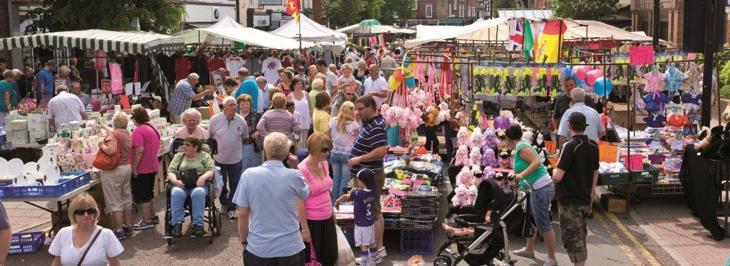
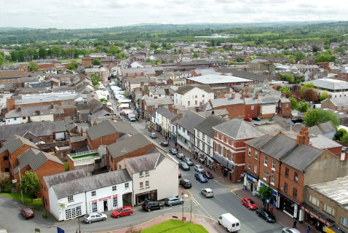
CONTENTS
Title Page No.
Introduction 3
About this report 4
About Mold Town Council 5-6
The seven well-being goals for Wales 7
Matrix showing cross-cutting across themes 8
Adoption of Mold Town Plan 9
Save a Life Appeal 10
Dementia Friendly Community Status 11
Crime Prevention 12-13
Financial Assistance 14-15
Sid Matthews Community Awards 16-17
Bilingual website 18
Mold Cemetery 19
Wild about Mold (Create your Space) 20-21
Bailey Hill Lottery Fund 22
Mold Spring Clean 23
Cittaslow 24
Historic Mold 25
Town Improvements 26
Mold Business Forum 27
Volunteering 28
Queens 90th Birthday Celebrations 29
Music events/festivals 30
North Wales Blues & Soul Festival 31
Novemberfest 32
Celebrating Christmas 33
Santa Dash 34
A Competent Council 35
Mold Town Council Members 36
Calendar of meetings 2016/17 37 Contact Information 38

Introduction
Welcome to this Annual Report.
I hope that you will enjoy reading about the work of Mold Town Council and the people we serve.
I would like to thank the elected members and officers of the Town Council for their hard work this year.
I would also like to thank the many individuals and organisations who have worked with us to improve the wellbeing of the community of Mold.
Finally, I wish to thank everybody who donated towards my nominated charity this year, the “Save a Life Appeal”. So many people have made donations to help raise funds, and I am very grateful to you all. All monies raised will go towards placing at least 25 defibrillators at key locations around the town and raise awareness of as many community volunteers as possible to use the equipment, together with CPR and other key life saving techniques.

Councillor Anthony Parry
Mayor of Mold Town Council
2016/17

About this Report

Wales faces a number of challenges now and in the future, such as climate change, austerity, poverty, health inequalities and jobs and growth. To tackle these we need to work together. To give current and future generations a good quality of life we need to think about the long term impact of the decisions we make.

The Well-being of Future Generations (Wales) Act 2015 gives a legally-binding common purpose – the seven well-being goals – for national government, local government, local health boards and other specified public bodies. It details the ways in which specified public bodies must work, and work together to improve the well-being of Wales.

This report describes how Mold Town Council has contributed to the seven well-being goals for the community of Mold. The report includes details of some of our objectives for the future. The report covers the municipal year of Councillor Anthony Parry’s year of office as Mayor of the Town Council.
Councillor Parry’s year of office commenced May 2016 to May 2017.

Samantha Roberts
Town Clerk and Finance Officer to Mold Town Council
May 2017

About Mold Town Council
Mold Town Council was created in 1974 following the re-organisation of local government and the disbanding of Mold Urban District Council. It is one of 34 town and community councils in Flintshire.
Mold is the county town of Flintshire. Flintshire County Council became the unitary authority after a re-organisation of local government in Wales in 1996.
Mold has a population of 10,058 and for local government purposes the Town is divided into four electoral wards, Mold Broncoed, Mold East, Mold South and Mold West, with four town councillors representing each ward. The councillors were elected in May 2012 to serve a five-year term of office which ended May 2017.
A Town Mayor and Deputy Town Mayor are elected each year by the Council at the annual meeting, which is held in May. The Town Mayor can receive an allowance to cover the costs involved in undertaking civic duties; no other councillors receive payments other than expenses incurred whilst carrying out Town Council activities if they choose to make a claim.
Details of the elected members and how to contact them are available at www.moldtowncouncil.org.uk. Notices of meetings, agendas, reports and minutes can also be viewed here, along with many governance documents and other information about the Council.

Mold Town Council’s aims
- To promote and represent the community’s views and aspirations at local, county, regional and national levels
- To serve those who live in and work in Mold and those who visit the Town
- To promote Mold as a place to live, work, shop and invest in and a place to visit
- To provide effective and efficient services that give value for money and to improve those services as needed
- To strive to improve the quality of life for all residents of Mold

To achieve these aims, Mold Town Council has agreed the following objectives
- To consult with the community to establish its aspirations for the future
- To promote the vitality and viability of Mold
- To encourage and participate in, partnership and agency working with the public, private and voluntary sectors to achieve quality services in all areas for the betterment of Mold and its residents and visitors
- To promote sustainable policies that strive to improve the environment to meet the needs of residents and visitors for both the present and future
- To help create a socially inclusive and caring community that embraces all residents and which seeks to develop their well being, knowledge, understanding and mutual co-operation
- To strive for a pleasant, clean and safe environment
- To deliver quality services that provides value for money and to review those services on a regular basis
- To support local voluntary groups that seek to assist residents and visitors to Mold
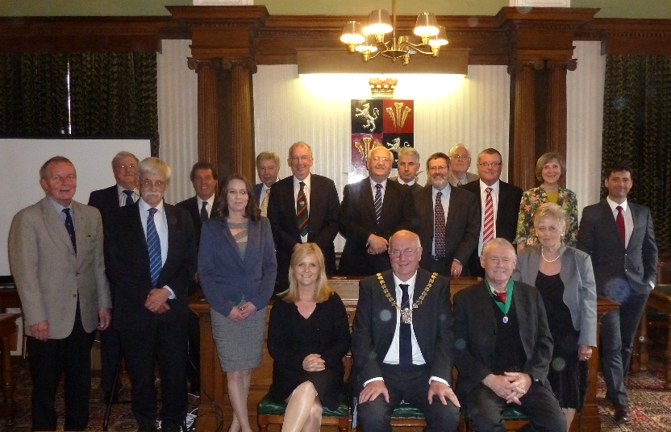
The Council derives almost all of its funds from its precept. This is an additional amount which is added to Flintshire County Council Tax bills based upon Mold Town Council’s estimated expenditure. For the financial year 2016/17 the Council estimated that it would need to spend £323,795. Of this amount, £244,419 was made up from the precept and the remainder was funded from other sources of income, such as cemetery income and grants.

Mold Town Council 2016/17

Further information about the Council’s finances, including its annual accounts, can be seen at www.moldtowncouncil.org.uk. This report includes examples of many of the Council’s services which are delivered to all age groups in a variety of forms. The report describes Mold Town Council services which contribute to the well-being of Mold and its community.

The seven well-being goals for Wales

The well-being of Future Generations (Wales) Act 2015 outlines seven well-being goals which need to be considered when drawing up local objectives. A description of each well-being goal and the issues identified within that theme is provided below. All of the issues identified in this needs analysis are cross-cutting and impact on more than one of these spheres of well-being.

Prosperous (1) | An innovative, productive and low carbon society which recognises the limits of the global environment and therefore uses resources efficiently and proportionately (including acting on climate change); and which develops a skilled and well-educated population in an economy which generates wealth and provides employment opportunities, allowing people to take advantage of the wealth generated through securing decent work.
Resilient (2) | A nation which maintains and enhances a biodiverse natural environment with healthy functioning ecosystems that support social, economic and ecological resilience and the capacity to adapt to change (for example climate change).
Healthier (3) | A society in which people’s physical and mental well-being is maximised and in which choices and behaviours that benefit future health are understood.
More equal (4) | A society that enables people to fulfil their potential no matter what their background or circumstances (including their socio economic background and circumstances).
Cohesive communities (5) | Attractive, viable, safe and well-connected communities.
Vibrant culture and thriving Welsh language (6) | A society that promotes and protects culture, heritage and the Welsh language, and which encourages people to participate in the arts, and sports and recreation.
Globally responsible (7) | A nation which, when doing anything to improve the economic, social, environmental and cultural well-being of Wales, takes account of whether doing such a thing may make a positive contribution to global well-being.

Matrix showing cross-cutting across themes

Some of the contributions of Mold Town Council towards the well-being goals are cross-cutting and impact on more than one of these spheres of well-being. The grids below give an interpretation of how each issue might fit within the list of well-being goals.
(1) Prosperous |  | (2) Resilient | (3) Healthier | (4) More equal |  |  | (5) Cohesive |  |  | (6) Culture |  |  |  | (7) Global
 |  |  |  |  | 1 |  | 2 | 3 |  | 4 | 5 |  |  | 6 | 7
1 | Adoption of the Mold Town Plan
2 | Save a Life Appeal
3 | Dementia Friendly Community Status
4 | Crime Prevention and Reduction
5 | Financial Assistance
6 | Volunteering
7 | Queen’s 90th Birthday celebrations
8 | Sid Matthews Community Awards
9 | Bilingual Website
10 | Wild About Mold (Create your Space)
11 | Bailey Hill Heritage Lottery Fund
12 | Mold Spring Clean
13 | Cittaslow
14 | Music events/Festivals
15 | Historic Mold
16 | Celebrating Christmas
17 | Santa Dash
18 | Town Improvements
19 | Mold Business Forum
20 | North Wales Blues & Soul Festival
21 | November Fest

Adoption of the Mold Town Plan
Global
Vibrant
Cohesive
More equal
Healthier
Resilient
Prosperous

At a special meeting of Mold Town Council on Wednesday 15th March the Town Plan was approved and adopted by members, following extensive consultation the previous year.
From the first formation of the steering group back in early 2015, Mold Town Council was keen to support the production of a Mold Town Plan. The Town Council felt that it would provide an excellent opportunity for the whole community to express its views about the way Mold should develop in the future. The completed Town Plan describes how people who live and work here would like the community to develop, it identifies key facilities and services and it sets out the issues which need to be tackled if the town is to be improved for all residents according to the priorities chosen.
The vision of the Town Plan is by the year 2025, Mold will be an economic driver for North-East Wales and a must-see destination for visitors to the region. The local community, their families, friends and tourists will be able to enjoy the benefits offered by the Town’s heritage and its natural and economic assets. This will be supported by the shopping experience offered by the range of successful customer-focused retail, tourist and professional businesses creating wealth and new job opportunities.
The Plan will be a useful tool for the Town Council because it represents the collective voice of our electors, and will be reviewed periodically to ensure it remains relevant. The Plan will also be used to influence the emerging Local Development Plan of Flintshire County Council.
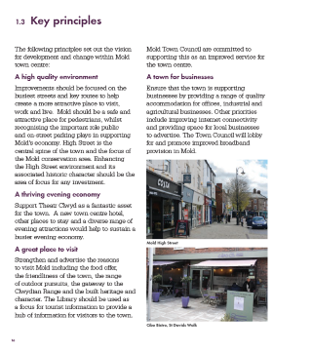
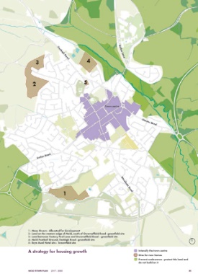
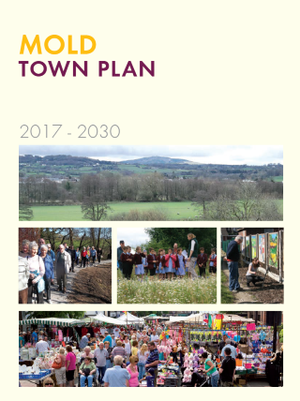

Save a Life Appeal
More equal
Healthier

During Councillor Anthony Parry’s term as Mayor, Mold Town Council has been raising money in aid of the Mayor’s ‘Save a Life’ campaign with the aim of placing 25 defibrillators at key locations within the town. The Town Council has also been raising awareness with as many community volunteers as possible to use the equipment, undertake CPR and apply other key life saving techniques. The target of 25 defibrillators has been reached and suitable locations have been identified to place the community defibrillators.
Cardiovascular disease accounts for a third of all deaths in Wales, leading to the very sad statistic of Wales having the highest prevalence of heart failure in the UK. The chance of surviving a cardiac arrest is just 3% in Wales, this increases to 49% and above when effective CPR is performed with a defibrillator within 3-5 minutes of collapse and this was one of the important drivers for our ‘Save and Life’ campaign in Mold.
The Town Council has offered a number of free training sessions on how to use the defibrillators and basic CPR/life saving advice. To date over 400 people of all ages have benefited from the training, including four of the six schools in the town.

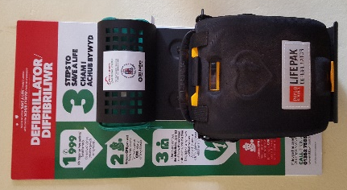
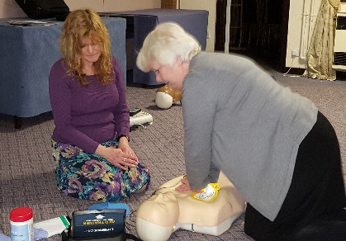

Dementia Friendly Community Status
Cohesive
More equal
Healthier

During Councillor Carol Heycocks term of office in 2014 her chosen charity was Alzheimer’s Society where over £10,000 was raised in aid of the charity. One of the aims from the fund raising was to aid Mold in achieving Dementia Friendly Community status.
As a result of the campaign the Mold Dementia Friendly Steering Group was establish with Councillor Carol Heycocks representing the Town Council on the steering group. The aim of the steering group is to work with businesses in the town to met the criteria set out by the Alzheimer’s Society to achieve ‘Working Towards becoming Dementia Friendly’ status.
In February 2017 Mold Town Council was awarded the Certificate for meeting the criteria and is now able to display the logo on all its literature. In order to achieve the status the Town Council met the following pledges:
- 50% of Mold Town Councillors have attended a Dementia Friends session and arrangements are in place for the remaining councillors to attend;
- Provide a quiet place;
- Identified a designated dementia lead for the organisation;
- Promote the use of positive language and challenge stigma;
- Provide meeting space free of charge for dementia friend’s sessions and for the Mold Steering Group to meet;
- Alzheimer’s Society was the Mayor’s charity for the year 2014/15 and raised in excess of £10,000 to support people living with dementia.
An Alzheimer’s Society survey revealed that 69% of people with dementia said that the main reason they stop going out is a lack of confidence. Mold achieving Dementia Friendly status will help people living with dementia to remain part of the community, be more active in the local area and live better, more fulfilled lives.
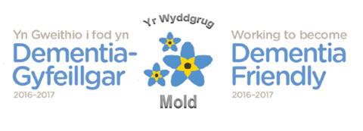

Crime Prevention and Reduction
Cohesive

Flintshire Against Business Crime
During 2016 Flintshire Against Business Crime (FABC) were aiming to set up a new radio link system for the businesses of Flintshire, similar to the successfully run scheme in Chester.
The schemes potential benefits aim to provide businesses of Flintshire with the following:
- Up to date digital radios with a network fit for purpose;
- Back office intelligence support for businesses to share intelligence on crime and criminals affecting them;
- A link to the CCTV suite at County Hall in Mold who can direct cameras as appropriate where they exist or if necessary use their radio link to the Police Control room;
- Police Officers/PCSO’s will also carry radios so they can hear what is going on in their area;
- Aspirationally, it is hoped that protective services such as Streetscene and Enforcement officers will carry radios linking them into the system;
- In Chester the scheme has seen a 26% reduction in shop theft and is acknowledged to have improved relationships between businesses themselves and also with police and council services
The total set up cost of the network with an initial role out of 40 radios came online in August 2016 was £34,000. Previous subscriptions to the analogue radio link have provided a surplus but demand for the Radio’s was much greater than the initial 40 and in order to meet this demand further funding was sought by FABC from Town and Community Councils in order to support the initiative and ensure its success. The scheme is designed to be self-sustaining within the first 12 months.
Mold Town Council recognised the importance of the scheme having subscribed to the earlier analogy scheme and agreed to fund the £1000 required for Mold to subscribe to the scheme to benefit the businesses within the town. The Mold Town Manager is actively engaged in supporting and facilitating a positive and effective relationship between all parties.

Shop Watch
We work closely with North Wales Police and support Shop Watch which meets once a month within the town. National and Independent Retailers in the town meet with the Town Council and Police to discuss crime affecting the business community, share intelligence and implement initiatives to prevent and reduce both crime and disorder.
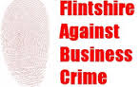

www.disc-net.org/chester
CCTV
Through a Service Level Agreement with Flintshire County Council since 1999, Mold Town Council fund the current CCTV provision in the Town. This equates to 12 fixed operational cameras in the Town and is subject to an ongoing programme of modernisation via the adoption of digital technology. The cost of the service for 2016/17 was £6,135.
The aim of these services and activities is to provide a safer environment for our community.

www.flintshire.gov.uk/en/Resident/Community-Safety/Closed-Circuit-Television-(CCTV).aspx

Financial Assistance
Vibrant
Cohesive
More equal
Healthier

We support organisations which help people with particular needs in Mold. Through the Financial Assistance Grant Scheme the Town Council awarded grants to voluntary or charitable groups based or working in Mold in 2016/17.
Such groups included:
Flintshire & Wrexham Online Watch Link (OWL) - A charitable organisation which develops and supports Neighbourhood watch schemes and Neighbourhood participation in crime prevention/reduction to work to a more cohesive neighbourhood through the promotion of working together for the safety, wellbeing of people, their properties and environment to bring about a cohesive community. There are 1105 members from Mold.
Emerge Community Arts - Emerge deliver music and drama projects for young people and adults across Flintshire who experience learning difficulties. Aiming to build self confidence, develop social and communication skills. There are currently 15 members from Mold aged between 20-50 years.
Relate Cymru - Relate provides counselling services for individuals, relationships, families, young people and sex therapy.
ROC Mold Youth Cafe - The cafe has activities which includes, console games, table football, pool, table tennis, music, cookery, baking, beauty tips, drug awareness, alcohol awareness, and sexual health advice.

Mold Food & Drink Festival - The festival now in its 11th year, incurred additional costs last year due to their 10th Anniversary celebration. The Mold Food & Drink Festival is a showcase for local produce and also attracts food and drink producers from around the country. The Festival is recognised as one of the best and most successful in Wales, attracting more than 13,000 visitors and 120 food and drink producers every year.
Shelter Cymru - Shelter Cymru provide housing advice services for all of Flintshire, including free legal representation. There are two weekly advice surgeries for the Mold Community and the surrounding area, supporting 1276 housing problems in the last year and over 774 people, 333 of whom were children
Buckley & Mold Lions Club - A Charitable organisation with the main focus of fund raising for local charities and individual causes.
Nightingale House - Nightingale House Hospice provides specialist palliative care to the communities of Wrexham, Flintshire and Denbighshire. It is estimated that the costs of running the hospice is £2.8m with only 20% of that being provided by the Health Board and Welsh Government. The remainder of the costs need to be raised through a variety of fundraising events
Parents of Autism working Together - This is a newly established charitable organisation set up through Action for Children. The aim of the group is to support parents and carers of children and young people who have been or are waiting for an autism diagnosis. Introducing guest speakers to educate and advise. Also offering relaxation elements by providing varied complimentary therapies at little or no cost to the group.
North Wales Chronic Pain Support Group - This is a new group that seeks to help people constructively to navigate the world of chronic pain. Providing support workshops, wellbeing courses, alternative therapies and monthly group sessions. The group is currently liaising with FLVC to obtain a free venue in Mold with a view to offering an additional monthly meeting on an evening for those in employment.
FDF (Flintshire Disability Forum) - FDF are based in Mold and provide advice and information services about disability issues. There are 4 social groups for adults with disabilities in Holywell, Buckley, Mold and Sandycroft where they have guest speakers, outings and activities. There are currently 50 members living in Mold. The organisation has recently been chosen by Disability Wales to set up a Centre for Independent Living to be based in Mold

Sid Matthews Community Awards
Cohesive
More equal
Healthier

The Town Council each year invites nominations for the “Sid Matthews Community Service Awards”. The awards, presented by the Mayor, are in memory of the late Sid Matthews who was the first Town Clerk of Mold from 1974 to 1988.

There are four awards, which recognise outstanding voluntary service and / or outstanding achievements within the community of Mold by:

a) An individual who lives within the Town of Mold;

b) An organisation based in Mold;

c) A young person who lives within the Town of Mold; and

d) A youth organisation based in Mold.

Successful nominees are invited to attend the Annual General Meeting (AGM) of the Town Council and are presented with a plaque of the Town crest together with a monitory gift in recognition of their achievements.
The successful nominees in 2016 were:
For “Outstanding Voluntary Service or Achievements by a Young Person”: Miss Maddison Spencer – for her achievements in dance. In previous years she has won Mold’s Got Talent, but her most recent achievements are for being chosen by a panel of judges to represent Wales in the Dance World Cup 2016. Maddison will be performing a solo modern routine at the event which is taking place in Jersey in June this year. Maddison is the youngest dancer to have been selected from her Dance School, and the school is the only one from North Wales representing Wales as the others are from the South.

For “Outstanding Voluntary Service or Achievement by an Individual”: Mr Peter Fuller – for his act of bravery. Mr Fuller intervened in a brutal attack motivated by racial hatred on a gentleman in Tesco, Mold. The attack inflicted serious injuries upon the victim but without the brave and courageous intervention by Mr Fuller it could well have been much worse. The victim, his family and the town are indebted to Mr Fuller for such a selfless act.

For “Outstanding Voluntary Service or Achievements by a Local Organisation”. Cambria Band – From Mold, the band has performed over 40 events in 2015. They are fantastic ambassadors for the Town with their stirring marching tunes and promotion of the Welsh culture. They celebrated 10 years in 2016. Anyone can join regardless of means; any donations made for performances are used to pay for instruments, uniforms and the cost of travel to events. The band welcomes all young people and has found that some troubled youngsters have managed to turn a corner through their association with the band.

For “Outstanding Voluntary Service or Achievements by a Local Youth Organisation” Young Dragons which is the umbrella organisation for the young uniformed youth group of volunteers. The young people are making a combined contribution to the community of Mold by helping to raise money for charitable organisations locally and nationally, improving the environment, and being available to help local groups who need extra pairs of hands. The uniformed youth groups help at fund raising events, community events, remembrance services and parades and civic events.
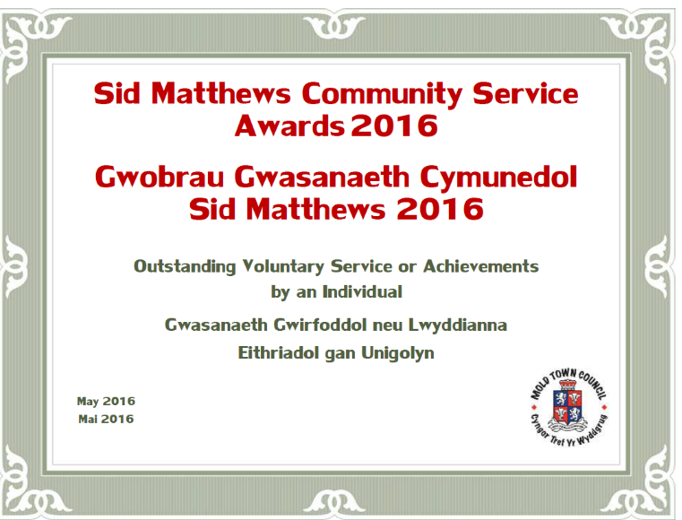

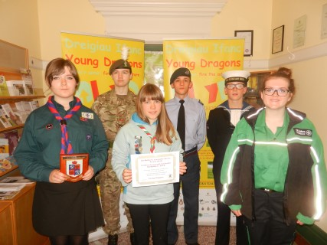
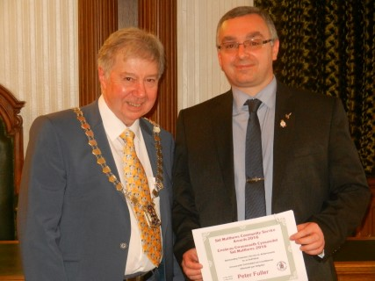
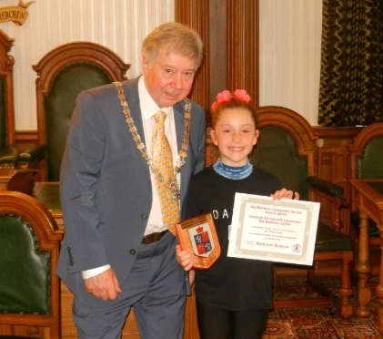
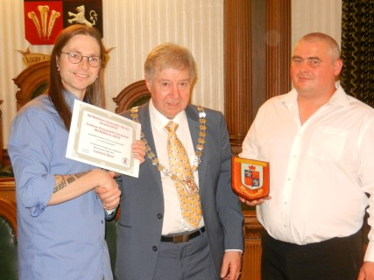
Bilingual Website
Globally
Vibrant
cohesive
More equal

The Council’s Welsh Language Scheme was approved in 2008. It was reported in the last Annual report that the scheme had been reviewed and it was recognised that some areas of the Scheme had not been implemented. The work to correct this has now been addressed. The Town Council’s bilingual website is now fully operational and live.
In addition the Town Council has met with representatives from the local Welsh speaking community with the aim of increasing the Town Councils knowledge and understanding of the needs of the community it serves. The Town Clerk has also begun taking Welsh lessons to help improve the accessibility of the Town Council. The Town Councils budget has been increased to meet the needs of bilingual translation.
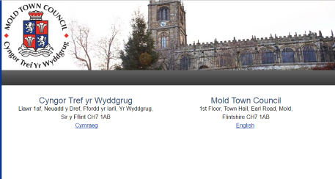
Mold Cemetery, Alexander Road
Resilient
Prosperous

Mold Town Council manages and maintains the only active burial site within the Town. The Cemetery is located on Alexandra Road, Mold and extends over an area of 2.20 hectares. The Cemetery was opened in 1877 and there have been approximately 8924 interments (burials and cremations). In 2013 we opened our cemetery extension which it is hoped will continue to serve the town’s needs for the next 15 years. This year we have planted fruit and nut trees in the Memorial Orchard at the new Cemetery Extension with students from Coleg Cambria and Cittaslow Mold representatives with the help of Keep Wales Tidy, the Cemetery Staff and the County Council’s Ecologist. The trees were donated by Flintshire County Council as part of their ‘Pollinator Friendly Scheme’.

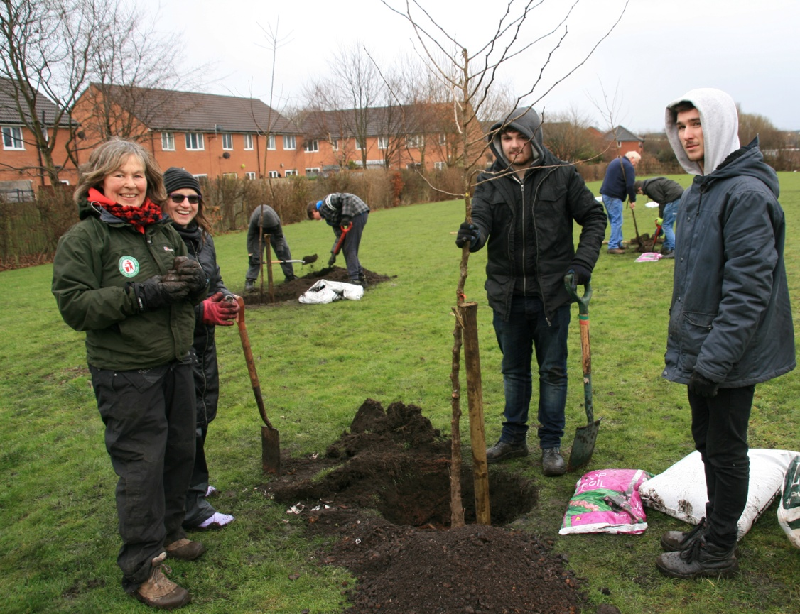
Fruit and nut trees in Cemetery Memorial Orchard, off Gas Lane, Mold. Planted by volunteers - students from Coleg Cambria Engineering and Cittaslow Mold, with help from Keep Wales Tidy, Cemetery staff and FCC Ecologist.

Wild about Mold (Create your Space)
Prosperous
Globally
Vibrant
Cohesive
Healthier
Resilient

Over the past 3 years, the Town Council’s Wildflowers and Footpaths Group has been seeking to progress the creation of a pedestrian-friendly ‘Green Band’ around Mold – an initiative which fits comfortably with its status as the first Cittaslow town in Wales. The initial focus was on trial planting, but other issues began to emerge as the project unfolded, covering access, public rights of way, and the idea that the Band could be extended beyond the town itself. The Create Your Space initiative and our partnership with North Wales Wildlife Trust offered a timely opportunity to address some of these key areas and make the Green Band a reality for communities across Mold (and beyond).
This project brought together a wide-ranging partnership of Flintshire-based organisations united by an interest in the outdoors: North Wales Wildlife Trust (NWWT), Mold Town Council, Cittaslow Mold, The Ramblers (Clwydian Group), Walkabout Flintshire and Flintshire County Council.

Wild About Mold is based around the town of Mold and its connections to surrounding villages along the Alyn and Wheeler Valley, including Rhydymwyn, Hendre, Nannerch and Afonwen. It aims to help communities including primary and secondary school children, walkers, cyclists, food- growers, the less physically active and the socially isolated.
The project is community-driven and also complements a range of local, regional and national initiatives, most notably the:
• Mold Sense of Place Study, which sets the scene to the Mold Town Plan
• Mold Town Plan which sets out a vision for the future of Mold and its development
• Alyn & Chwiler Living Landscape Feasibility Study, which explores opportunities for biodiversity enhancements and public access throughout the Alyn and Wheeler Valleys
In October 2016 the project successfully reached the second stage in a funding bid from the Big Lottery Fund’s Create Your Space Programme. If successful at the second stage the project would attract up to £1.5m to create a network of accessible wildlife-rich areas in Mold and the surrounding villages of the Alyn and Wheeler Valleys.
Unfortunately the Wild about Mold scheme was not successful in the Create Your Space Big Lottery awards at the second stage.
Of the 63 projects in Wales that were invited to apply for the first stage development funding, 16 were successful including Wild About Mold. Fifteen of these submitted applications for the second stage requesting a total of £21,146,674, however Big Lottery only had a budget of £7,714,140 to spend on Create Your Space. (Applicants were invited to make bids of between £500,000 and £2m).
The work undertaken by the Wild About Mold partners will not be wasted. It can be used to inform the future programme of work and to make applications to other relevant funding pots. The stronger, but unfunded Create Your Space projects (including Wild About Mold) are being encouraged to consider re-working their applications and submitting them to People & Places (P&P) programme.
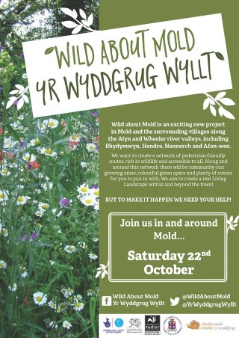
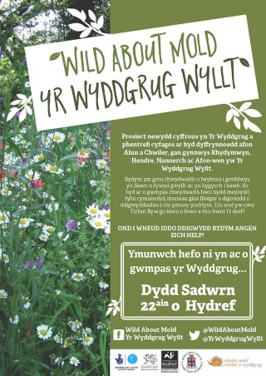
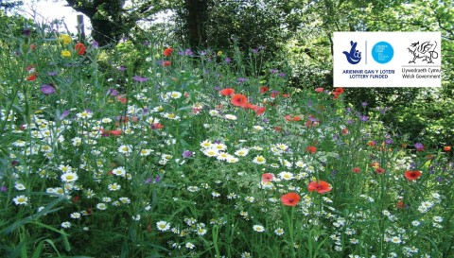

Bailey Hill – Heritage Lottery Fund
Global
Culture
Cohesive
More equal
Healthier
Prosperous
Resilient

Flintshire County Council in partnership with Mold Town Council and the Friends of Bailey Hill group has received a Heritage Lottery Fund (HLF) Parks for People award to improve this important public park - the birthplace of Mold.
Bailey Hill can be found at the heart of the historic market town of Mold. At its core is the remains of an extensive 11th Century Motte and Bailey Castle. The site is unusual having two Baileys, which is unique in Flintshire. Other notable features include an early custodian’s cottage, a cenotaph and a Gorsedd stone circle erected in 1922/3 for the proclamation of the National Eisteddfod.
The award of the initial HLF support and development funding of £43,900 will enable detailed work on conservation, interpretation, activity planning and governance of the site, to take place over the next year. Consultants Harrison Design (a local Mold company) has been appointed to coordinate the development work with the help of volunteers.
Once this background work is completed, a full application for just less than one million pounds will be made to HLF and, if this in turn is also successful, the improvements outlined in the Bailey Hill master plan will go ahead. These improvements include new access, paths and flower beds, interpretation of the historic features and the creation of a flexible, attractive event / activity space.

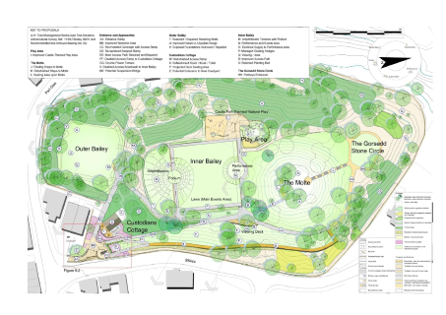

Mold Spring Clean
Global
Culture
Cohesive
Resilient

Friday 31st March, Saturday 1st April & Sunday 2nd April 2017
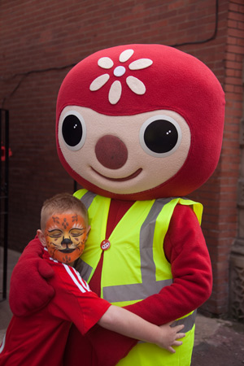
2017 Spring Clean was very successful with 610 plus volunteers taking part over the four day event, including many new businesses getting involved. Over 315 bags of rubbish were also collected.
The aim of Mold Spring Clean is to make the town a pleasant environment to live,
work and play in, and generate community pride for everyone.
Volunteers representing all areas of the community are involved in the annual Mold Spring Clean including schools, local groups, businesses and residents of Mold.
During the spring clean, volunteers are sent out in groups to give the town a spring clean. Improvements include, litter picking, clearing footpaths, tidying flowerbeds, painting benches with opportunities for everyone to participate. Such is the success of this initiative the Town Council now also loan out equipment to neighbouring communities and groups to carry out cleaning activities of their own.
The Town Council also received the support of Flintshire County Council and Keep Wales Tidy during the weekend.

Cittaslow
Global
Vibrant
More equal
Cohesive
Healthier
Resilient
Prosperous

In 2006 Mold became the first Welsh town to achieve Cittaslow status. The aims and objectives of Cittaslow Mold are shaped by the principles of Cittaslow UK which are:

- Encouraging diversity rather than standardisation.
- Supporting and encouraging local culture and traditions.
- Working for a more sustainable environment.
- Supporting and encouraging local produce and local products.
- Encouraging healthy living especially through children and young people.
- Working with the local community to build these values.

These form the overall vision of Cittaslow Mold that are achieved through the delivery of specific goals. The Town Council strives to recognise the Cittaslow Goals within all activities it carries out. These goals include the environment, infrastructure, the quality of urban fabric, encouragement of local produce and products and hospitality and community. Through our Cittaslow status we have attracted interest nationally and internationally, hosting visits to share best practice. In March of this year the town welcomed the Secretary General of Cittaslow International from Italy, Mr Pier Giorgio Oliveti.

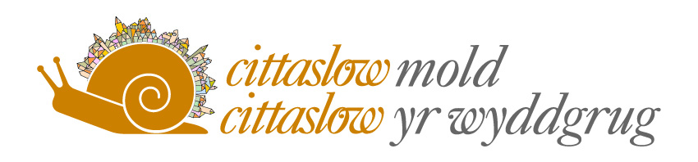

www.cittaslowmold.co.uk

Historic Mold
Culture
Cohesive

Over two days in November Mold Town Council opened its doors and invited members of the public to come along to the Mold Town Hall and take a step back in time.
A large display of photographs and memorabilia showing the history of Mold over the last 150 years, along with the historic Council Chamber were available for the public to view as doors opened from 3.00pm until 8.30pm.
During the evening, local Historian and Author David Rowe gave a short talk on the Abbreviated History of Mold; a virtual illustrated tour of Mold's history, including one of the top ten treasures of the British Museum, 'The Mold Gold Cape', the Alleluia Victory, Norman Conquest, the unfortunate Mayor of Chester, the link with Henry VII, Wars, Churches and Chapels, Pubs and shops, the County Town, the Royal Academician founder and hymn writers, poets & authors.
During the event, a calendar which was produced to raise money for the Mayor of Mold’s ‘Save a Life’ appeal was on sale. The calendar entitled Historic Mold had a number of pictures depicting key buildings and events within the town over a 100 year history.
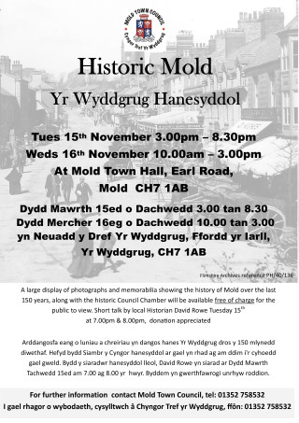

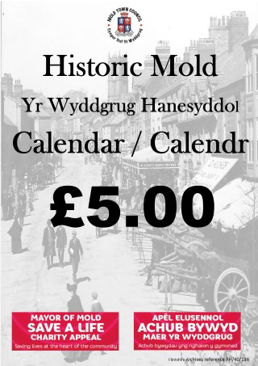

Town Improvements
Resilient
Prosperous

It was reported last year that the Town Council were working in partnership with Flintshire County Council on the town’s off street parking strategy enabling the Town Council to secure funding in the region of £140,000 from the town’s car parks to invest in visitor infrastructure projects.

This work has continued into 2016/17 with the installation of the six new Gateway signs into the Town on New Brighton Road, Ruthin Road, Flint Road, Denbigh Road, Chester Road and Wrexham Road and to resurface a majority of footpaths in the Town Centre. There have also been an additional six Tourist Information Points installed at Love Lane, Griffiths Square, New Street and King Street car parks, near the steps from King Street and on the Library wall in the Daniel Owen Precinct.

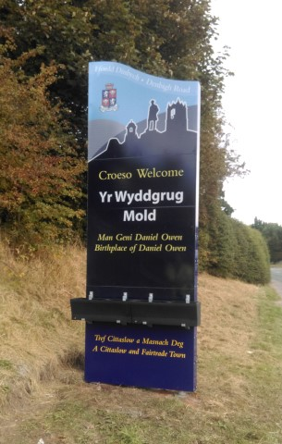

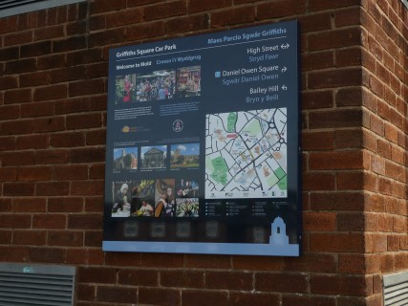

Mold Business Forum
Cohesive
More equal
Resilient
Prosperous

The Town Manager represents the Town Council on Mold Business Forum, which provides business owner/managers with trading entities in Mold, a vehicle through which likeminded people can get together to share experiences, learn from each other and mentor each other. The MBF also provides excellent wider networking opportunities both through events but also in conjunction with other local organisations, most notably the North Wales and Chester Chamber of Commerce.
There is a very diverse set of businesses in the Mold area from small start-up companies through to those that have been operating for many years. They include niche high-tech specialists, professional service companies, and consultants, many of whom are UK- and world-leaders in their specialist sectors. Mold has the reputation as outperforming many larger towns in terms of its retail offering that includes many independent retailers as well as branches of national chains. Mold has a vibrant town and community, and hinterland of surrounding villages, contribute to the Mold area being an excellent location in which to base any company.

www.moldbusinessforum.wales

Volunteering
Global
Vibrant
Cohesive
More equal
Healthier
Resilient
Prosperous

We actively encourage and welcome volunteers to assist with the many events organised in the town. The volunteers have the opportunity to build their skill set and gain experience within a working environment.
Some examples of the level of volunteers engaged to assist with events include:
Mold Spring Clean March 2017 – in excess of 650
Bailey Hill HLF/Mold Green Band (Environmental projects) – in excess of 50
Various music festivals (Blues & Soul, Novemberfest, Live of the Square) – in excess of 100
Santa Dash – in excess of 50
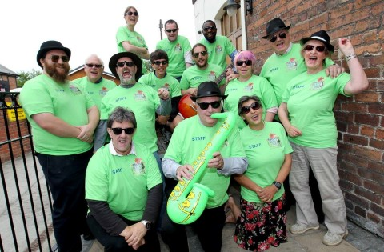
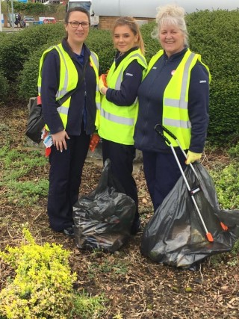
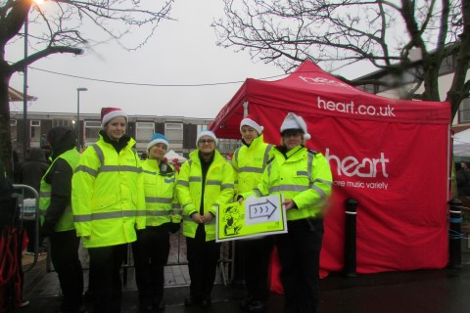

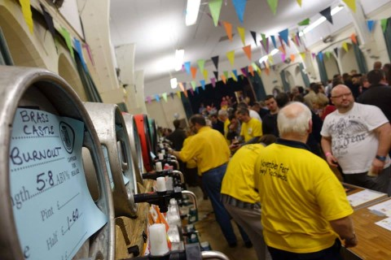
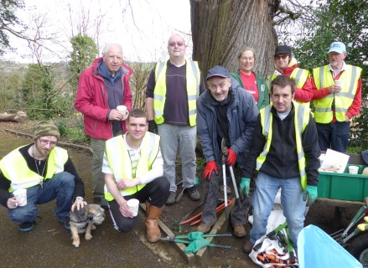

© Alison Mclean at The Photo Foundry

Queens 90th Birthday Celebrations
Vibrant
Cohesive

To celebrate the Queen’s 90th birthday the Town Council invited residents of the town who were turning 90 in 2016 to join the Mayor and other members of Mold Town Council for afternoon tea to celebrate Her Majesty the Queen’s 90th Birthday and their own 90th year on Friday 10th June at the Greenroom, Llys Jasmine, Mold.
The invitation was open to all residents born during 1926 and who celebrated their own milestone 90th birthday that year along with a guest.
Also on 12th June 2016 Mold Town Council hosted Mold Celebrates - a family event with “Music through the Decades” on Daniel Owen Square, the event coincided with the Queen’s celebratory street party on The Mall.

The town’s celebration of Her Majesty the Queen’s official 90th was a FREE family event with musical & dance performances from the 1920’s through to modern day.

In conjunction with the event, the Town Council sent Her Majesty a GIANT Birthday greeting from Mold in the shape of a 4ft Birthday card coordinated by Mold Town Council and produced & donated by local company, Smurfit Kappa. The front design had a picture drawn by a pupil from each of the four primary schools, who ran their own independent competition for a winning design to feature. Once the card had been signed by businesses and residents from the town, the card was delivered to Her Majesty.
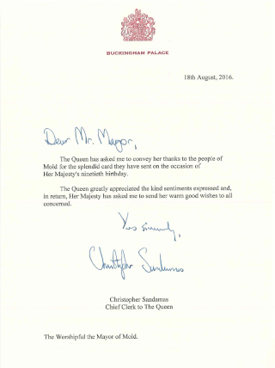
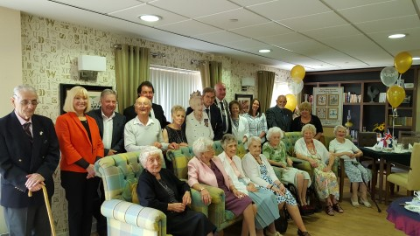

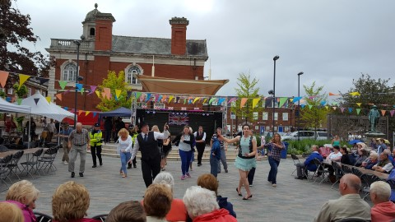

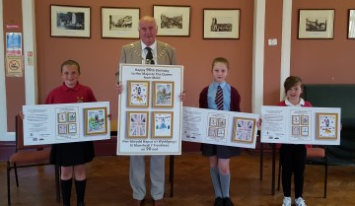

Music events/Festivals
Culture
Cohesive

Mold is fast becoming a town of events and at the heart of many of the events is the support of Mold Town Council. This can include directly organising an event, or financial support or merely providing an enabling role to assist event organisers to deliver a safe and successful event for the town.
The following calendar of events was provided for the community of Mold and wider during 2016/17:
Mold Carnival - Financial Support and volunteers from Mold Town Council.
North Wales Blues & Soul Festival – Organised, delivered and funding by Mold Town Council and its volunteers
Flower Festival – Enabling role provided by Mold Town Council.
Queen’s 90th Birthday celebrations – Organised, delivered and funded by Mold Town Council.
Mold Food & Drink Festival - Financial Support and volunteers provided by Mold Town Council, and Town Councillor involvement in organising committee.
Daniel Owen Festival – Financial Support from Mold Town Council and Town Councillor involvement in organising committee.
Town Bonfire – Financial Support from Mold Town Council.
Novemberfest – Organised, delivered and funded by Mold Town Council and its volunteers.
Remembrance Sunday – Organised by Mold Town Council
Christmas Lights switch on evening – Organised, delivered and funded by Mold Town Council and its volunteers
Santa Dash – Organised, delivered and funded by Mold Town Council and its volunteers.
Mayor’s Christmas Concert – Organised and delivered by Mold Town Council

North Wales Blues & Soul Festival
Culture
Cohesive

In August the Town Council and the organising Committee, staged the third Blues and Soul festival in the Town. The family friendly festival played host to some of the biggest names in blues and soul. Held over three days on Kendrick’s Field in Mold, the event had seasoned performers and up and coming talent.
Headlining acts included Doug McLeod, Laurence Jones, Ainsley Lister and five times winner of ‘Blues in Britain’ magazine’s ‘Best Femail Vocalist’ UK, Connie Lush.
As well as it being a great event the Town, it attracts visitors from across the UK and further afield providing benefits of increased footfall and economic spend in the town’s businesses over the weekend. Local publicans also welcome some of the performing artists to play in their local pubs following the event to help increase trade.
All proceeds from the festival are used to go towards putting on other events in the town.
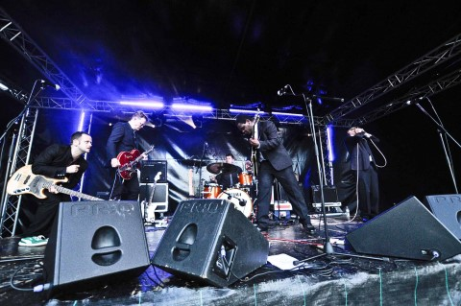
www.www.nwbluesandsoul.co.uk

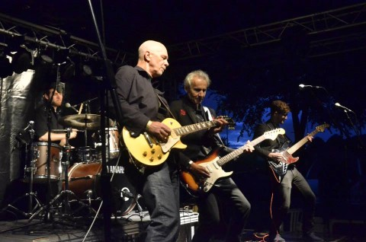

Novemberfest
Culture
Cohesive

The Town Council’s fifth Novemberfest was held in November at St. Mary’s Church Hall, Mold. The festival of real ale, real food and real entertainment was a success with the participation of other business in the town. There were over 30 real ales, real lagers and local cider with great wines with food and entertainment over the weekend.
All proceeds from the festival are used to go towards putting on other events in the town.
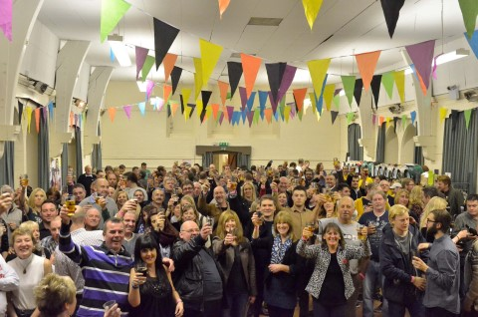

Celebrating Christmas
Culture
Cohesive
More equal

The Town Council hosted three events for the Christmas period, the Annual Christmas Lights Switch on, the Christmas Concert and the Santa Dash.
The Christmas Light’s Switch on welcomed pupils from Mold Alun, Maes Garmon, Ysgol Glanrafon, Bryn Coch and Bryn Gwalia who performed a selection of festive songs on the Daniel Owen Square. Mold Town Concert Band also entertained the crowds with festive tunes. Our bi-lingual Father Christmas switched on the Christmas lights and afterwards met with children in his grotto, whilst the fun fair entertained older children.
The Christmas Concert at St. Mary’s Church was a huge success, with special guest appearance from Welsh Tenor Rhys Meirion and his daughters Elan and Erin Meirion. There were also performances from other local artists. All proceeds from the event went towards the Mayor’s ‘Save a Life’ Charity Appeal. In 2016 nearly £20,000 was spent on Christmas light upgrading, including phasing in of LED bulbs, and essential health and safety works.
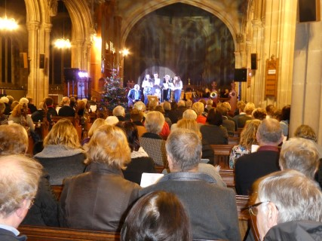
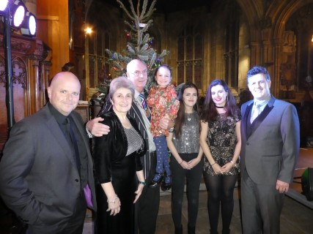

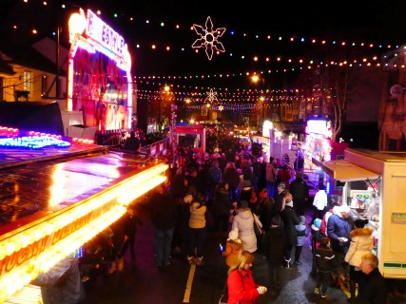
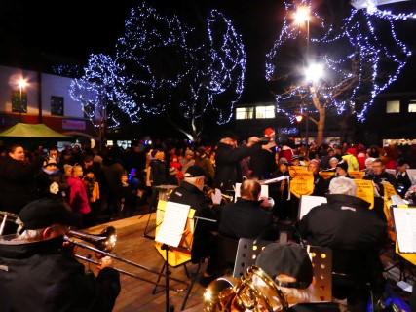
Santa Dash
Culture
Cohesive
More equal
Healthier

On Sunday 11th December the Town Council delivered its second Santa Dash around the town. The Santa Dash was open to all ages and abilities and covered a 1.4 mile circular route around the town, starting from the Daniel Owen Square on Earl Road. For a fee of £10 the Town Council provided Santa Suits to all those over the age of 12, with children under 12 allowed to enter free of charge. All proceeds were donated to the Mayor’s ‘Save a Life’ appeal. Runners were welcome to raised sponsorship for their own chosen charities or groups.
This year’s event saw over 400 people take part and was widely regarded as a huge success.
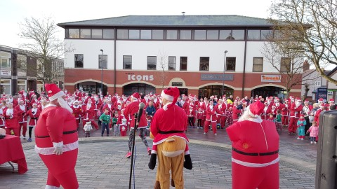

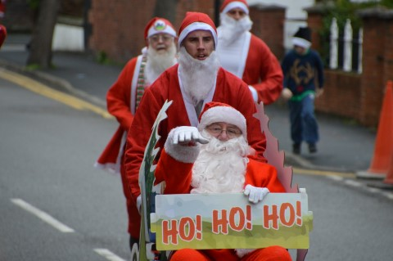

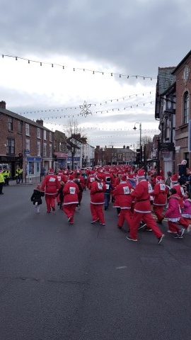
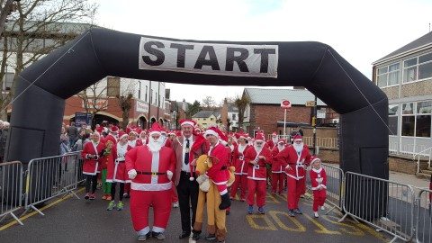
A Competent Council

Finally, these are changing times for Community & Town Councils. Mold faces many new challenges and opportunities. It is important that we are ready to face these challenges: to be Fit for the Future.

A number of ‘competency’ tests are emerging to help Community Councils determine how well equipped they are to meet the challenges ahead. These tests will bring more consistency to the sector, with higher standards of governance and financial management.

These tests might include:

- a democracy test: - Councillors must be elected at either an ordinary election or a by-election;

- a capability test: - the Community Council must employ a clerk with relevant professional qualifications, such as the Certificate in Local Council Administration (CiLCA).

- a capacity test: - the Council has a minimum annual budget of £200,000; and

- a governance test - the Council has sound financial management and internal control systems. It should also meet other criteria such as having a website on which it publishes agendas, minutes and accounts and is contactable by email.

- The Town Council is also subject to both internal and external audit

The Town Council undertook an audit during the year, to see how it faired against these tests. Here are our findings:
- All councillors have been declared elected. None have been co-opted.

- The Clerk has attained her CiLCA qualification in 2016.

- The town’s annual budget is over £200,000

- The Town Council has sound management and financial systems. Its accounts are scrutinised by others. Agendas, minutes, accounts and contact details can be viewed at www.moldtowncouncil.org.uk. The Community can e-mail the Clerk to the Council at townclerk@moldtowncouncil.org.uk. A Charter is in place to govern our relationship with Flintshire County Council.

BRONCOED WARD
Haydn Bateman | Cortonwood, Blackbrook Road, Sychdyn. CH7 6LT | 01352 754510 / 07714 155446 | haydn.bateman@yahoo.co.uk  haydn.bateman@flintshire.gov.uk
Ray Dodd | Retired from Council 2017
Gareth Williams | Glan-yr-Afon House, Brook Street, Mold. CH7 1PH | 01352 754442 / 07917 054135 | garethwilliams300@gmail.com
Carol Heycocks | Retired from Council 2017
EAST WARD
Chris Bithell | The Coppins, 88 Hendy Road, Mold.CH7 1QR | 01352 754578 | Chris.bithell@hotmail.com  christopher.bithell@flintshire.gov.uk
Richard Brookes | Retired from Council 2017
Bryan Grew | 7 Maes yr Haul, Mold. CH7 1NS | 01352 759673 / 07547 446118 | bgrew@sky.com
Andrea Mearns | Rosscote, Gwernaffield Road CH7 1RE | 01352 757687 /  0752 3097900 | mearns@tiscali.co.uk
SOUTH WARD
Geoff Collett | 8 Ffordd Hengoed, Mold. CH7 1QD | 01352 756582  07917 054138 | geoffcollett2004@yahoo.co.uk
Anthony Parry | Brynwood, Bryn Coch Lane, CH7 1PS | 01352 754423  07710 360717 | info@doddsauctioneers.co.uk
Robin Guest | 36 Ffordd Pentre, Mold. CH7 1UY | 01352 757408  07812 016917 | tobyreggie@hotmail.com  robinguest@keeneandkelly.com
Philip Thomas | Retired from Council 2017
WEST WARD
Brian Lloyd | Pwll Glas Farm Cottage, Gwernaffield Road, Mold CH7 1RQ | 01352 753107  07734 579898 | rbl.pwllglas@yahoo.co.uk
Bob Gaffey | 55 Dreflan, Mold. CH7 1DF | 01352 751886 | gaffeybobby@aol.com
Geoff Matthias | 7 Dreflan, Mold. CH7 1DE | 01352 753481  07515 297833 | geoffmatthias@hotmail.com
Karen Hodgkinson | 4 Elm Drive, Mold, CH7 1SG | 01352 751795 | karenhodgkinson4moldwest@gmail.com

Full Council and Committee meetings 2016/17
Full Council
2016/17
May | Jun | Jul | Aug | Sep | Oct | Nov | Dec | Jan | Feb | Mar | Apr
11th*  25th | 29th | 20th | - | 28th | 26st | 30th | - | 25th | 22nd | 29th | 26th
*Denotes the AGM. **Denotes a Special Meeting.

Personnel Committee
2016/17
May | Jun | Jul | Aug | Sep | Oct | Nov | Dec | Jan | Feb | Mar | Apr
- | 8th | - | - |  | - | 14th | - | - | - |  | -

Policy & Audit Committee
2016/17
May | Jun | Jul | Aug | Sep | Oct | Nov | Dec | Jan | Feb | Mar | Apr
 |  |  | - | 12th | - |  | - |  | - | 13th | -

Planning Committee
2016/17
May | Jun | Jul | Aug | Sep | Oct | Nov | Dec | Jan | Feb | Mar | Apr
5th | 1st | 18h |  | 5th | 3rd | 7th | 5th | 4th | 6th | 6th | 3rd

Cemetery Committee
2016/17
May | Jun | Jul | Aug | Sep | Oct | Nov | Dec | Jan | Feb | Mar | Apr
- | - | 13th | - | - | - | 9th | - | - | - | 8th | -

Community Development & Regeneration Committee
2016/17
May | Jun | Jul | Aug | Sep | Oct | Nov | Dec | Jan | Feb | Mar | Apr
- | - | 13th | - |  | 11th |  | - | 17th | - |  | 11th

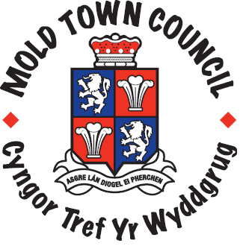
Contact Information

Mold Town Council
Town Hall
Earl Road
Mold
Flintshire
CH7 1AB

Telephone: 01352 758532 www.moldtowncouncil.org.uk

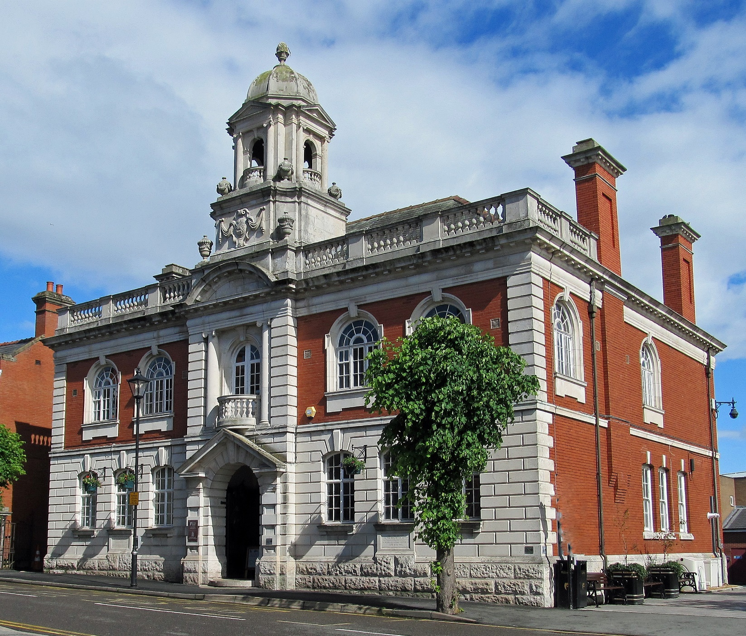

Clerk and Finance Officer: Samantha Roberts
Telephone: 01352 758532 Email: townclerk@moldtowncouncil.org.uk
Support Officer: Jane Evans
Telephone: 01352 758532 Email: supportofficer@moldtowncouncil.org.uk
Town Manager: Dave Hill
Telephone: 01352 751819 Email: tcm@moldtowncouncil.org.uk
Cemetery Superintendent:
Arfon Williams-Cooke
Cemetery Assistant:
Michael Gallagher
Address:
The Lodge, Mold Cemetery, Alexandra Road, Mold, Flintshire CH7 1HJ Telephone: 01352 753820

Follow us on social media for all the latest news
Facebook moldtowncouncil Twitter @moldtowncouncil

