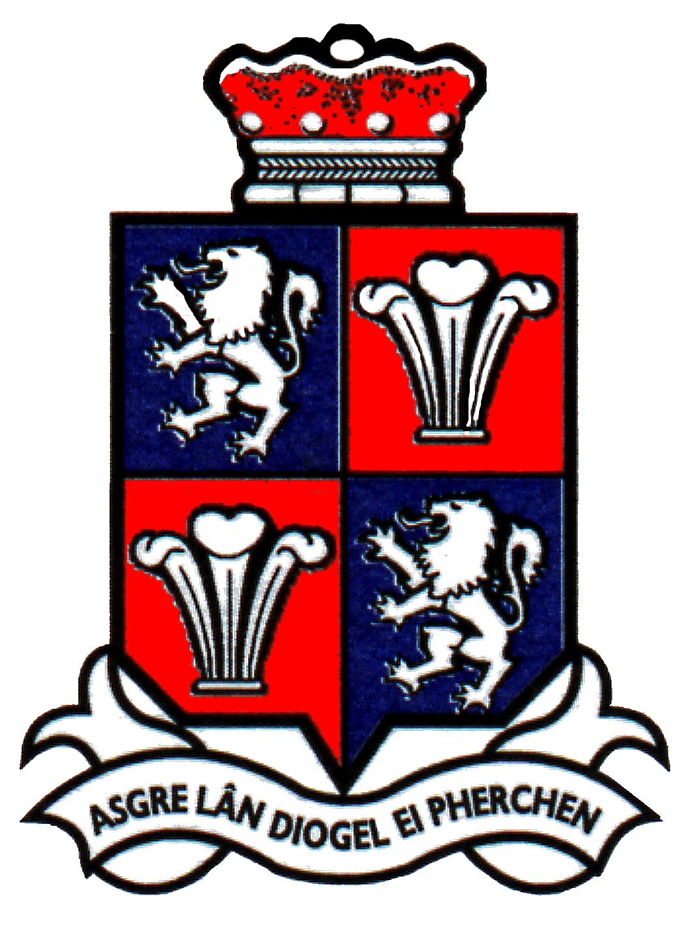

Schedule of Meetings 2023/24

The following dates are recommended for meetings of Mold Town Council during the next year (maybe subject to change):

Suggested start time: 6.00pm

17th May 2023
28th June 2023
26th July 2023
27th September 2023
25th October 2023
29th November 2023
31st January 2024
28th February 2024
27th March 2024
24th April 2024

Annual Meeting 8th May 2024

Schedule of Committee Meetings

The following dates are suggested for meetings of Mold Town Council Committees during the next year:

Cemetery Committee

24th May 2023 - 6pm
6th September 2023
6th December 2023
6th March 2024

Planning Committee (Zoom)

5th June 2023 - 6pm
3rd July 2023
31st July 2023
28th August 2023 (prov.)
25th September 2023
23rd October 2023
20th November 2023
18th December 2023
15th January 2024
12th February 2024
11th March 2024
8th April 2024
6th May 2024

Community, Development & Regeneration Committee
Tbc.

June 2023
November 2023
February 2024
April 2024

Personnel Committee

14th June 2023
13th March 2024

Budget Committee

13th December 2023

Policy & Audit Committee

21st June 2023
20th September 2023

Financial Assistance Committee

14th June 2023
17th January 2024

Word/General/Miscellaneous/ScheduleofMeetings

