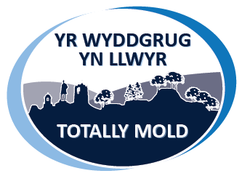
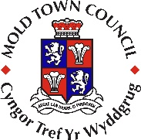

Totally Mold Shop Local Voucher scheme
Registration Form
Company Name:
Company Address:
Please include postcode
Contact Name:
Position in company:
Contact Number:
Email address:
Website
Social Media
Bank details for payment | Account name:  Sort Code:  Account Number:

Category – please select category that is most relevant to your business (only choose one that is most relevant to your business as this is how your business will be categorised in our promotion of the scheme):
Animal/Pet Care |  | Fashion |  | Hotel/Accommodation
Book/Newspaper |  | Food/Drink (retail) |  | Music/Entertainment
Charity |  | Gifts/Jewellery |  | Printing/Photography
Children/Toys/Games |  | Health/Beauty/Hair |  | Restaurants/Cafés/Pub
Craft/Sewing/Alterations |  | Hire/Builders Merchant |  | Sport/Sport Equipment
Electrical/Phones |  | Home/Garden/Florist |  | Travel/Transport/Leisure
Please give a short description about your products/services (max 50 words):

Opening hours - enter time in boxes provided:
Business Hours | Monday | Tuesday | Wednesday | Thursday | Friday | Saturday | Sunday
Open
Close

Please return the completed form, along with your business logo to business@moldtowncouncil.org.uk or postal address; Mold Town Council, Town Hall, Earl Road, Mold CH7 1AB
If you are offering discount or special offer in exchange for Totally Mold vouchers, please let us know so we can help you promote. Make sure you keep us updated on your special offers for Totally Mold Vouchers by emailing events@moldtowncouncil.org.uk and we will share this information within our promotion and on social media.
To be completed and signed by authorised person within the company
I the undersigned would like to register for the Mold Town Council Totally Mold Shop Local Voucher Scheme. I agree to the terms and conditions as shown overleaf and confirm acceptance of Mold Town Council Totally Mold Shop Local Voucher for any goods or services the business (as shown named on this registration form) provides.
Signed |  | Date
Name |  | Job Title

See overleaf for Terms & Conditions of Voucher scheme.

#TotallyMold

Terms & Conditions of Mold Town Council Totally Mold Shop Local Voucher Scheme

All vouchers have to be returned to Mold Town Council along with invoice and redeemed vouchers for payment.

Mold Town Council will issue payment to participating business only on receipt of invoice and accompanying redeemed voucher, payment will be issued within 28 days of receipt of invoice.

No transactions charges will apply to shopping vouchers sold or issued by Mold Town Council.

Vouchers can be used in participating business only, these may change from time to time and an up to date list can be requested from Mold Town Council.

Participating businesses may offer discount or special offers as part of the Totally Mold Voucher scheme at their own discretion

Mold Town Council accept no responsibility for lost, stolen or damaged vouchers.

Totally Mold Vouchers may not be exchanged for cash at any time.

Vouchers may be exchanged for goods or services of a higher value, on payment of the difference

If sale is less than value of voucher, no change is to be issued. Vouchers are redeemable in their entirety only and may not be redeemable incrementally.

Damaged vouchers or vouchers which do not have the agreed security features will not be accepted by the Mold Town Council.

It is the participating business responsibility to ensure all staff likely to deal with the vouchers are familiar with the scheme and security features of the vouchers.

Mold Town Council will not accept any responsibility for claims, demands, losses, costs, expenses or liability of any kind whatsoever arising, suffered from, or in connection with, any transaction or dealing between the participating business and voucher holder or customer.

If a customer returns goods purchased with a voucher, participating business should apply their own refund policy and ensure that it is clear at the time of purchase.

Participating businesses must have no outstanding account with Mold Town Council in order to be reimbursed for presented vouchers.

Mold Town Council reserve the right to revise these terms and
conditions at any time.

Mold Town Council
Town Hall
Earl Road
Mold
Flintshire
CH7 1AB
01352 758532

