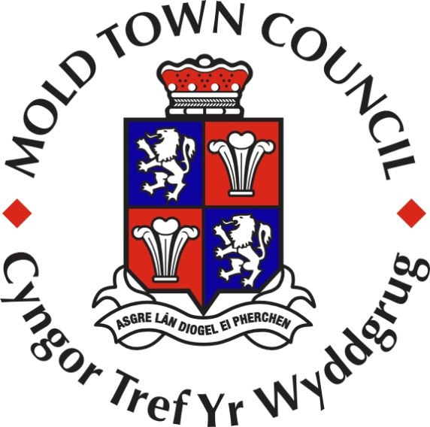

**MOLD TOWN COUNCIL ANNUAL REPORT**

**MAY 2015 TO APRIL 2016**

**CONTENTS**

* Introduction
* About this report
* About Mold Town Council

The well-being goals:

* Chapter 1 – A Prosperous Mold
* Chapter 2 - A Resilient Mold
* Chapter 3 – A Healthier Mold
* Chapter 4 – A More equal Mold
* Chapter 5 – A Mold of Cohesive Communities
* Chapter 6 – A Mold of Vibrant Culture & Thriving Welsh Language
* Chapter 7 – A Globally Responsible Mold
* Chapter 8 – A Competent Council
* Appendix 1 – Mold Town Councillors 2015/16
* Appendix 2 – Full Council and Committee meetings 2015/16

**Introduction**

*Welcome to this Annual Report.*

*I hope that you will enjoy reading about the work of Mold Town Council and the people we serve.*

*I would like to thank the elected members and officers of the Town Council for their hard work this year.*

*I would also like to thank the many individuals and organisations who have worked with us to improve the wellbeing of the community of Mold. I have been especially pleased to see young people taking an interest in our activities and services.*

*Finally, I wish to thank everybody who donated towards my nominated charity this year, the Stroke Association Wales. So many people have donated money or gifts to help raise funds, and I am very grateful to you all. All monies raised will go towards establishing the Stroke Associations very first North Wales “Strike a Chord” choir in Mold. This will bring stroke survivors together to enjoy singing as a group with a professional tutor and hopefully performing at events in the town. The Stroke Association also aim to hold art classes in Mold with the money raised.*

Councillor Brian Lloyd

Mayor of Mold Town council

2015/16

**About this Report**

This report describes how Mold Town Council has contributed to the economic, social and environmental wellbeing of Mold using Wales-wide sustainable development principles. The report includes details of some of our objectives for the future.

The Well-Being and Future Generations (Wales) Act 2015 places the future of good health as a priority of Wales. Mold Town Council to show you how we are and also how we hope to work towards these aims in the future via this report. The report covers the municipal year of Councillor Brian Lloyds’ year of office as Mayor of the Town Council.

Councillor Lloyds’ year of office commenced in May 2015 to May 2016.

Samantha Roberts

Town Clerk and Finance Office to Mold Town Council

2016

**About Mold Town Council**

Mold Town Council was created in 1974 following the re-organisation of local government and the disbanding of Mold Urban District Council. It is one of 34 town and community councils in Flintshire.

Mold is the county town of Flintshire. Flintshire County Council became the unitary authority after a re-organisation of local government in Wales in 1996.

Mold has a population of 10,058 and for local government purposes the Town is divided into four electoral wards, Mold Broncoed, Mold East, Mold South and Mold West, with four town councillors representing each ward. The present councillors were elected in May 2012 to serve a five-year term of office.

A Town Mayor and Deputy Town Mayor are elected each year by the Council at the annual meeting, which is held in May. The Town Mayor receives an allowance to cover the costs involved in undertaking civic duties; no other councillors receive payments other than expenses incurred whilst carrying out Town Council activities if they choose to do so.

Details of the elected members and how to contact them are available at [www.moldtowncouncil.org.uk](http://www.moldtowncouncil.org.uk). Notices of meetings, agendas, reports and minutes can also be viewed here, along with many governance documents and other information about the Council.

**Mold Town Council’s aims**

* To promote and represent the community’s views and aspirations at local, county, regional and national levels
* To serve those who live in and work in Mold and those who visit the Town
* To promote Mold as a place to live, work, shop and invest in and a place to visit
* To provide effective and efficient services that give value for money and to improve those services as needed
* To strive to improve the quality of life for all residents of Mold

**To achieve these aims, Mold Town Council has agreed the following objectives**

* To consult with the community to establish its aspirations for the future
* To promote the vitality and viability of Mold
* To encourage and participate in, partnership and agency working with the public, private and voluntary sectors to achieve quality services in all areas for the betterment of Mold and its residents and visitors
* To promote sustainable policies that strive to improve the environment to meet the needs of residents and visitors for both the present and future
* To help create a socially inclusive and caring community that embraces all residents and which seeks to develop their well being, knowledge, understanding and mutual co-operation
* To strive for a pleasant, clean and safe environment
* To deliver quality services that provides value for money and to review those services on a regular basis
* To support local voluntary groups that seek to assist residents and visitors to Mold

The Council derives almost all of its funds from its precept. This is an additional amount which is added to Flintshire County Council Tax bills based upon Mold Town Council’s estimated expenditure. For the financial year 2015/16 the Council estimated that it would need to spend £296,718. Of this amount, £230,498 was made up from the precept and the remainder was funded from other sources of income, such as cemetery income and grants.

Further information about the Council’s finances, including its annual accounts, can be seen at [www.moldtowncouncil.org.uk](http://www.moldtowncouncil.org.uk).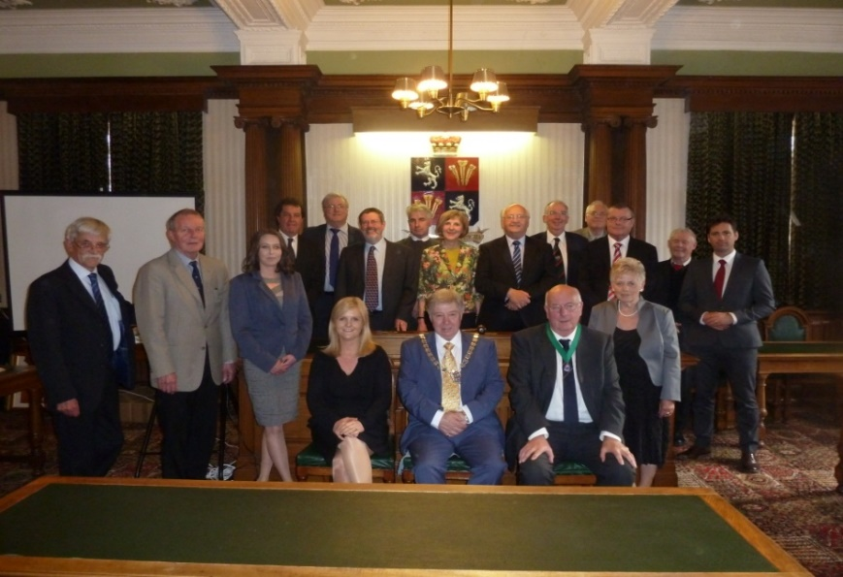 This report includes examples of many of the Council’s services which are delivered to all age groups in a variety of forms. The report describes Mold Town Council services which contribute to the well-being of Mold and its community.

***Mold Town Council 2015/16***

**Chapter One: A Prosperous Mold**

* **How did we do?**

We employ a Town Manager who works to enhance communication between providers and users of Mold Town Centre services and facilities. He co-ordinates the resources and interests of all stakeholders to enhance the quality, attractiveness and success of Mold. He contributes to the development and delivery of a shared vision for Mold Town and to undertake specific initiatives to improve its attractiveness, accessibility, economic viability and security.

The Town Manager coordinates the Mold Town Partnership which was formed in 2000 by a wide range of private and public sector businesses and organisations that share a common interest in ensuring the economic well- being of Mold. The Partnership includes the Town and County Council, Mold Business Forum and other local organisations who co-operate to influence and secure proactive developments, activities and initiatives within the town.

We are working on our Town Plan which once completed and approved will be used to inform Flintshire County Council’s Local Development Plan. The Mold Town Plan, once approved will also include the work being carried out on Community Asset Transfer. Flintshire County Council is working with local people to find local solutions to provide services. Local communities have a big opportunity to play their part and take responsibility for the provision of some local services and facilities which the County Council are stepping away from. These changes are necessary in view of the unprecedented reduction in government funding. However, the County Council hope that its community partners, like Mold Town Council, can help to maintain the most important and valued of these services.

We have carried out consultation with the residents and stakeholders of Mold to identify the assets and services which should be protected if funding can be found. We are also working very closely with Flintshire County Council at alternative delivery models to maintain these services for the community. Further dedicated consultation will be carried out in order to agree the approach to be taken.

We consider and respond to planning applications, protection of trees and highway issues.

We worked in partnership with Flintshire County Council on the town’s off street parking strategy enabling the Town Council to obtain funding in the region of £130,000 from the revenue from car parks to invest on the visitor infrastructure of the town. Projects included:

* + - New Gateway signs for the Town;
    - Implementing and delivery of a signage strategy to improve visitor road signs into the town;
    - Upgrading the heritage street lighting;
    - New Street car park improvements;
    - Visitor Information Points;
    - Daniel Owen Precinct lighting phase 2.

As a town that has many events during the year, we offer performers of all age and ability the chance to showcase their talent and skills, such as at our Christmas Concert at St. Mary’s Church, the Christmas Lights switch on and the Mayor’s Charity Concert at Theatre Clwyd.

* **How can we improve?**

We are building good relationships with the local business community. We will look to improve on this even more.

* **What you said during a survey held in November 2015:**

20% of respondents commented that the town’s livestock market should stay in its current location – it is part of the identity of Mold, helps the local economy, and supports local businesses and residents.

However, to the contrary, 11% of respondents wish to see the livestock market re-located, as it is currently in a prime central location that could be used for other purposes. Ideas included more retail, a hotel, or craft and food markets.

20% of respondents give their support for turning vacant town centre properties above shops, into flats, to encourage town centre living.

20% of respondents give support for a new hotel in the centre of Mold. A number of respondents felt this should be an affordable hotel to boost tourism and help grow the town’s economy. Three people commented that a new hotel should be situated next to the theatre.

13% of people recognised Theatr Clwyd as a key cultural asset of Mold and a real gem which needs to stay.

13% of respondents mentioned the current lack of suitable shops. Specifically, some felt there are too many charity shops, building societies, pubs, hairdressers and beauticians.

15% commented that they would like to see smaller, high quality, independent shops and restaurants, which support local businesses and produce. Some felt this could be encouraged through beneficial business rates for start up businesses and more flexible contract/lease arrangements for shorter term rents for business in the town centre.

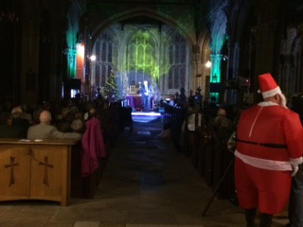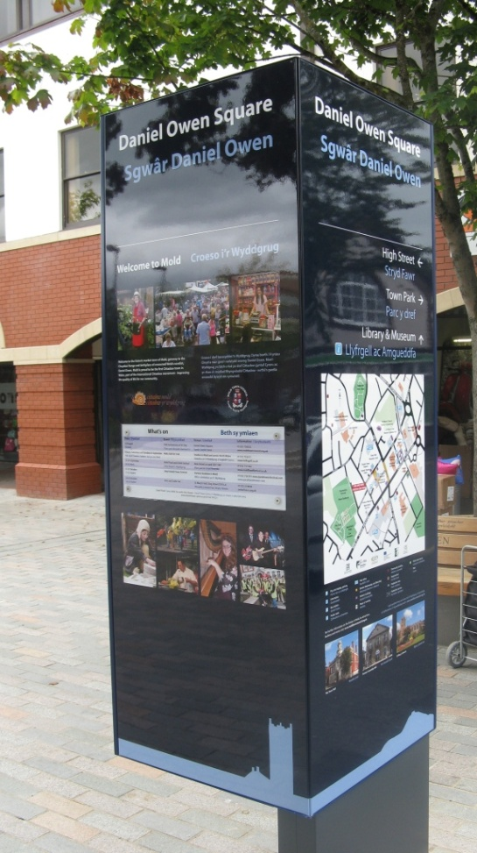

**Mayor’s Charity Christmas Concert December 2015**

**New Visitor Information Point   
 Daniel Owen Square**

**Chapter Two: A Resilient Mold**

* **How did we do?**

We encouraged and promoted sustainable solutions to environmental matters. We have a group who are working on developing a Green Band around the town. We are also working with Flintshire County Council on an application for Heritage Lottery funding for improvements to Bailey Hill, which if successful could see in the region of £1m spent on environmental improvements, improving the infrastructure of the site.

Mold Town Council manages and maintains the only active burial site within the Town. The Cemetery is located on Alexandra Road, Mold and extends over an area of 2.20 hectares. The Cemetery was opened in 1877 and there have been approximately 8924 interments (burials and cremations). In 2013 we opened our cemetery extension which it is hoped will continue to serve the town’s needs for the next 15 years. This year we have planted fruit and nut trees in the Memorial Orchard at the new Cemetery Extension with students from Coleg Cambria and Cittaslow Mold representatives with the help of Keep Wales Tidy, the Cemetery Staff and the County Council’s Ecologist. The trees were donated by Flintshire County Council as part of their ‘Pollinator Friendly Scheme’.

We have a yearly Blooming Mold competition encouraging local residents and children to take pride in their gardens, understand wildlife-friendly gardens and pollinator friendly planting.

We hold a yearly Mold Spring Clean which encourages participation from the junior schools, high schools local businesses and other volunteers from across the community to take part in cleaning the town and carrying out environmental projects.

Our members closely monitor the way the Council is run to ensure we use our resources wisely.

* **How can we improve?**

We will continue to look at ways of working with the community to encourage sustainability. We will work with our partners to make the best use of our resources.

* **What you said during a survey held in November 2015:**

23% of people said they supported better quality open spaces.

10% of respondents commented that existing open spaces within the town and in the surrounding areas (e.g. playing fields) should be protected. A small number of people would like to see spaces expanded for recreation and allotments.

Six people mentioned Bailey Hill as an underused asset in town which could be enhanced and promoted as a historic site.

Protecting wildlife and protecting trees in surrounding industrial areas is a key concern for a small number of consultees.

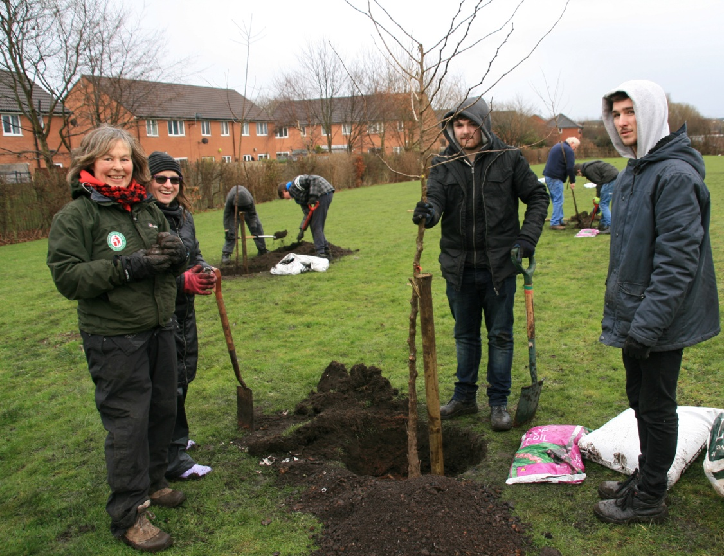

***Fruit and nut trees in Cemetery Memorial Orchard, off Gas Lane, Mold. Planted by volunteers - students from Coleg Cambria Engineering and Cittaslow Mold, with help from Keep Wales Tidy, Cemetery staff and FCC Ecologist***.

**Chapter Three: A Healthier Mold**

* **How did we do?**

The Town Council contributes annual funding to the Summer Play schemes which deliver a balanced programme of inclusive play opportunities to school children in Mold. The children are encouraged to learn and develop through play and given every opportunity to participate in active indoor and outdoor play.

The Town Council contributes annual funding to the Bubblegum Club at Parkfields. The Bubblegum Club is an open play facility that has been running for over ten years and is open to children aged between 5 and 12 years old from across Mold. Bubblegum has a programme of activities which incorporate a wide range of new experiences, including den building woodland craft/ bush craft.

In 2015 the Mayor of Mold’s Charity was the Stroke Association. Through the various fund raising events put on throughout the year £8,668.98 was donated to the Stroke Association. This money is being used in the local area and fund new schemes such as the Strike a Chord Choir for Stroke survivors. In addition to the money raised, the year was used to raise awareness of the risks of stroke. There were two ‘Know your blood pressure’ events where approximately 10 people tested were subsequently referred to their GP.

Continuing on from the previous year, we are working closely with the Alzheimer’s Society to raise awareness of Dementia. In addition we supported Buckley and Mold Lions with their prostate cancer campaign where screening was carried out on local men. From the local testing eleven men were identified as needing further testing.

* **How can we improve?**

We will keep the above arrangements under review to make sure that they still help us to serve the community in the best way.

As part of the reshaping of Flintshire County Council services programme, the Town Council is considering taking over responsibility for parks and open spaces within the Town to ensure continued play provision for the towns youth.

* **What you said during a survey held in November 2015:**

10% of respondents gave support for the old railway line to be used for cycle paths. A number mentioned the need to improve and invest in new cycle paths and routes.

Three people supported creating a safe cycle network, linking up with existing routes such as Deeside and the Sychdyn cycle route.

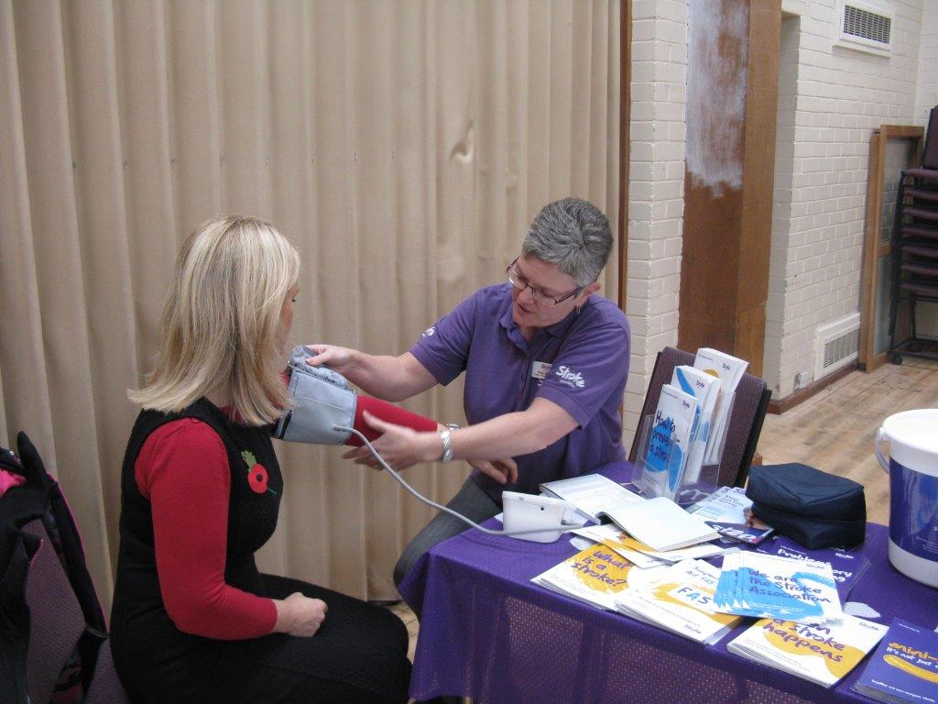

**‘Know your blood pressure’ event**

**Chapter Four: A More Equal Mold**

* **How did we do?**

We support organisations which help people with particular needs in Mold. Through the Financial Assistance Grant Scheme the Town Council awarded grants to voluntary or charitable groups based or working in Mold in 2015/16.

Such groups included:

* + Tandem Cymru
  + Flintshire Disability Forum
  + DAFFODILS (Disabilities and family friendships offering dependant integrated life skills)
  + Hafan Cymru
  + North Wales Deaf Association
  + Eye2Eye
  + Relate Cymru
  + Flintshire Diabetes Support Group
  + Playmates Playgroup

We actively encourage and welcome volunteers to assist with the many events organised in the town. The volunteers have the opportunity to build their skill set and gain experience within a working environment.

We believe in the voice of young people and have a Youth Council Committee for the junior and senior schools in the town. The Committee has four members representing the Town Council who hold regular meetings with the schools and their representatives. In February we visited Ysgol Maes Garmon and took part in the School Forum, members were asked many questions on the activities of the town council. We also received valuable feedback on the development of the Draft Mold Town Plan, particularly relating to the protection of key services in the town that are important to the young people.

The Town Council is represented on a number of organisations to help ensure opportunities are taken to offer community benefit. Such organisations include:

* Daniel Owen Community Association
* Mold Town Partnership
* Parkfields Management Committee
* Grosvenor Hall Committee
* Mold Fairtrade Group
* **How can we improve?**

We will continue to work with the Alzheimer’s Society to ensure Mold becomes a Dementia Friendly Community giving people living with dementia the same opportunities.

We are currently working on the Welsh translation of the Town Council’s website.

We have expressed an interest as a potential sub regional hub, providing Community Transport arrangements across a wider area.

Although the Council has good links with a number of religious organisations within the town we recognise that we need to develop this further with all denominations.

* **Some facts and figures:**

The Council increased its budget for grants to voluntary organisations for 2015/16. This means that we could support even more organisations who make such a difference to people’s lives.

* **What you said:**

*“DAFFODILS would like to offer our appreciation to Mold Town Council for their support of the children and young people’s charity.”*

*“Your donation to Hafan Cymru will greatly contribute to the delivery of the Freedom Programme for the vulnerable women that we support in Mold, They will now get the opportunity to learn how to avoid abusive relationships in the future in order to build a safer life for themselves and their children”*



**Volunteers helping to plant trees at the Cemetery**

**Chapter Five: A Mold of Cohesive Communities**

* **How did we do?**

We have strong links with the Local Planning Authority, Flintshire County Council, as a statutory consultee. In partnership with Flintshire County Council we assist with developing future plans for the growth of the town.

We are currently working on the Mold Town Plan with stakeholders from the town. Mold Town Plan is being drafted and will set out the vision for the town for the next 10-15 years. The plan builds upon previous consultations and studies including key principles identified in the Sense of Place Study, Mold Action Plan and Cittaslow goals.

An important part of the process is the ongoing community engagement which will help inform the plan. Two consultation events were facilitated to give local people and business in Mold the opportunity to share their ideas for the future of Mold.

The exhibitions presented the main principles of the plan and gave people the opportunity to complete questionnaires covering a number of themes relevant to the future of Mold. People also had the opportunity to e-mail their ideas and comments if they were unable to attend the events.

One theme of the Town Plan will be Empowering Communities and Enhancing Services, with a vision of developing a place for all ages including improving the provision for young people with child-friendly facilities as well as provision for older people.

We provide and support many community events throughout the year, with an average of one event every month, which included Mold Spring Clean, VE Day and VJ Day commemorations on the Daniel Owen Square, the Town Carnival, Bailey Hill Festival, North Wales Blues & Soul Festival, Mold Food & Drink Festival, Daniel Owen Festival, Novemberfest and December Festive fun including the town’s first Santa Dash. These events have helped to build a strong community cohesion encouraging volunteers from across the town, and also giving charities and community groups opportunities to promote their work within the town.

We work closely with North Wales Police and support Shop Watch which meets once a month at the Town Hall. National and Independent Retailers in the town meet with the Town Council and Police to discuss crime affecting the business community and share intelligence.

We believe in ensuring the Town Council support as many activities/events as possible. As such the Mayor last year accepted 160+ invitations to represent the town as a wide variety of opening and events including a Bangladeshi New Year, Nightingale House for afternoon tea, EMERGE Community arts for people with learning disabilities and the Poppy Appeal Community Awards.

Once again the town won Flintshire County Council’s Best Kept Community Award for a Town of over 5000 people.

* **How can we improve?**

We want to encourage more members of the public to attend our events and get more involved with matters relating to Community Asset Transfer and the protection of public services in the town. We want to encourage others to hold regular events and performances on the Daniel Owen Square. We will make these a priority for the future.

* **What you said during a survey held in November 2015:**

There was general support that communities should be empowered to make change and that this requires good communication between the Town Council and residents.

People have motivation but no knowledge or skills to get involved in their community - people need to be trained and supported to know what to do.

A community forum online should be started to encourage discussion about issues.

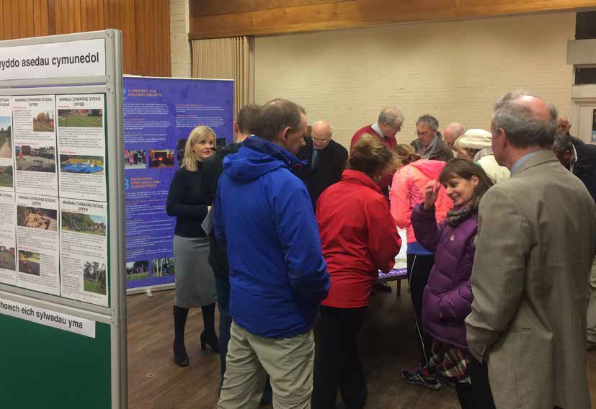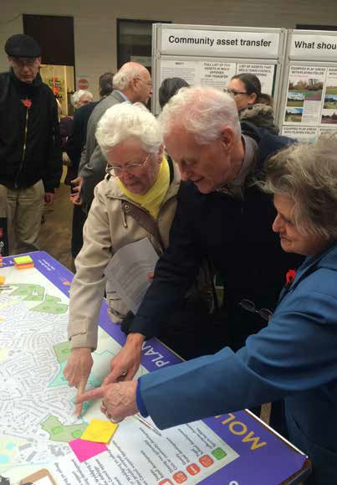

***Consultation events on the Mold Town Plan during November 2015***

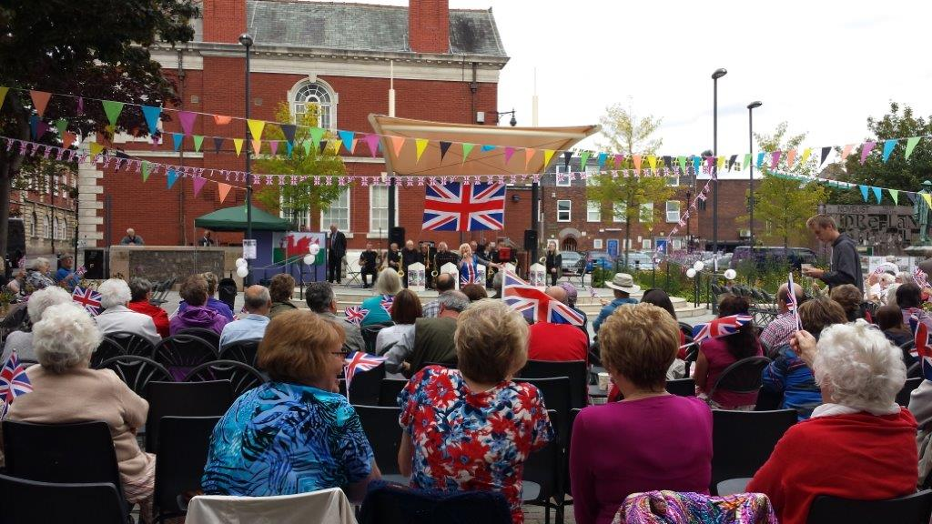

**VJ Commemorations August 2015**

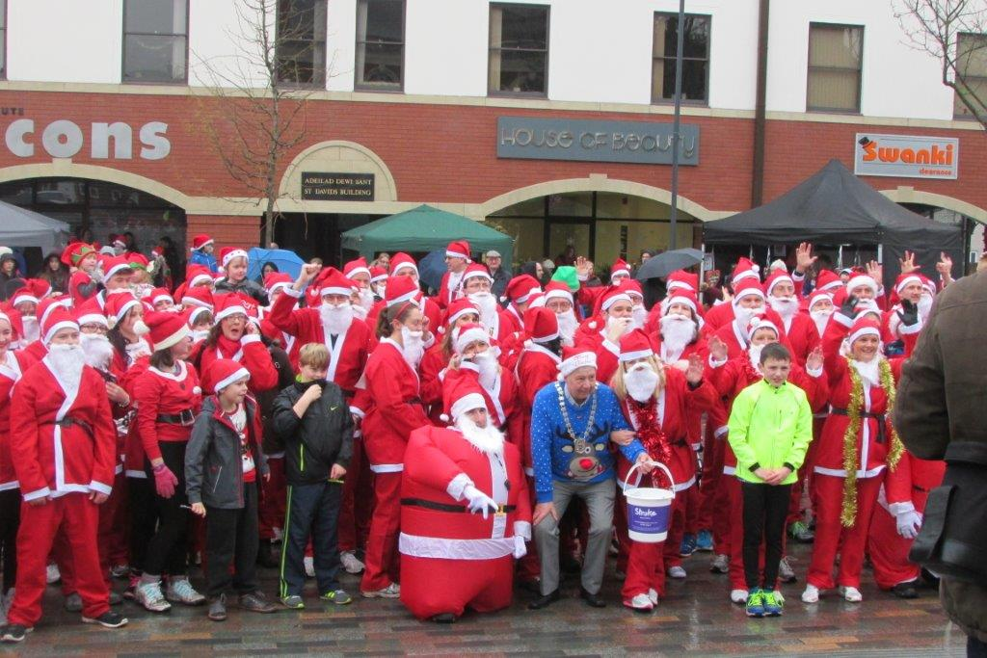

**Santa Dash December 2015**

**Chapter Six: A Mold of Vibrant Culture and Thriving Welsh language.**

* **How did we do?**

We funded local organisations that promote culture and the arts in Mold, and example of this is Mold & District Choral Society, Mold Town Band and the Daniel Owen Festival.

In May 2014 a new post was created for a Support Officer working 16 hours per week. Due to the growing success of the role and the support given to organising many of the events funded by the Town Council the hours were increased in November 2015 to 32 hours per week.

Through Cittaslow Mold, we organised the Bailey Hill Festival with local music performed live on the Inner Bailey. On the Gorsedd site there were magical stories, and on the Outer Bailey the Samhain Welsh Medieval Society recreated early 14th century daily life transporting visitors back to this fascinating time through hands-on-history.

The Mayor hosted two concerts, a summer concert in Theatr Clwyd where Flint Male Voice Choir and Manon and Lleuwen Hedd sang songs in Welsh. The Christmas concert was at St. Mary’s Church where Manon and Lleuwen returned to sing festive songs

* **How can we improve?**

The Council’s Welsh Language Scheme was approved in 2008. This has recently been reviewed and it was recognised that some areas of the Scheme had not been implemented. The work to correct this is currently being carried out for instance by introducing the Town Council’s Bilingual website.

* **What you said during a survey held in November 2015**

A number of comments were made about Mold’s strong Welsh identity. There is support to enhance Mold’s identity as the gateway to Wales. It is important to remember the bilingual nature of Mold and the rich cultural heritage of our vibrant Welsh language community which is and integral part of what makes Mold such a special place.



**The Annual Bailey Hill Festival**

**Chapter Seven: A Globally Responsible Mold**

* **How did we do?**

Once again Mold has retained its Fairtrade Town Status, through the work of the Mold Fairtrade Group who hope to continue to improve on this and retain it year on year.

We are working to create the Mold Green Band.

Mold Spring Clean is an award winning community initiative that has been operating since 2009 and has featured over 1000 members of the community participating in cleaning up the town. Springy, the Mold Spring Clean Mascot is used to reinforce important environmental messages such as recycling, not dropping litter, self responsibility and to help instil pride in the community to the young (and young at heart).

Performance over the past 8 years continues to be impressive thus demonstrating the town council’s long term commitment to the town’s future.

|  |  |  |  |  |  |  |
| --- | --- | --- | --- | --- | --- | --- |
|  | **Mold Spring Clean Performance** | | | | | |
|  |  |  |  |  |  |  |
|  | **Volunteers** | **Hours contributed** | **% town litterpicked** | **Bags rubbish** | **Renovations** | **Comments** |
|  |  |  |  |  |  |  |
| **2009** | 300+ | not collected | 70% | 360+ | Chewing Gum removed  Footpaths pressure washed | Fly tipping addressed |
| **2010** | 650+ | not collected | 85% | 450+ | 21 benches stained  Ponterwyl made over | |
| **2011** | 800+ | 1300+ | 90% | 480+ | Main planters in town refreshed  Bollards, etc painted | |
| **2012** | 850+ | 1300+ | 95% | 400+ | Lagoons footpath built  DO Precinct benches stained | |
| **2013** | 700+ | 1200+ | 80% | 300+ | DO Square benches  River cleared | **It Snowed!** |
| **2014** | 1000+ | 2200+ | 90% | 250+ | Maes Gwern land  Bovril Path campers sites  Bus Station benches | |
| **2015** | 620+ | 1600+ | 70% | 200+ | Cemetery field & path renovated | Heavy rain and winds |
| **2016** | 720+ | 2000+ | 95% | 280+ | Pigeon detritis removed  Benches to be stained  Llys Jasmine resident planted own flowers | More businesses involved |

We recycle waste paper and plastics in the offices and town cemetery. Waste is collected and sorted for recycling.

As the first Town in Wales to be awarded Cittaslow Status the Council strives to recognise the Cittaslow Goals within all activities it carries out. These goals include the environment, infrastructure, the quality of urban fabric, encouragement of local produce and products and hospitality and community. Through our Cittaslow status we have attracted interest nationally and internationally, hosting visits to share best practice. 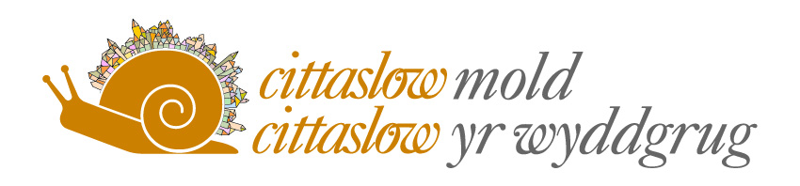

* **How can we improve?**

We will strive to keep our working practices environmentally friendly, supporting sustainable approaches to recycling, waste management and use of resources.

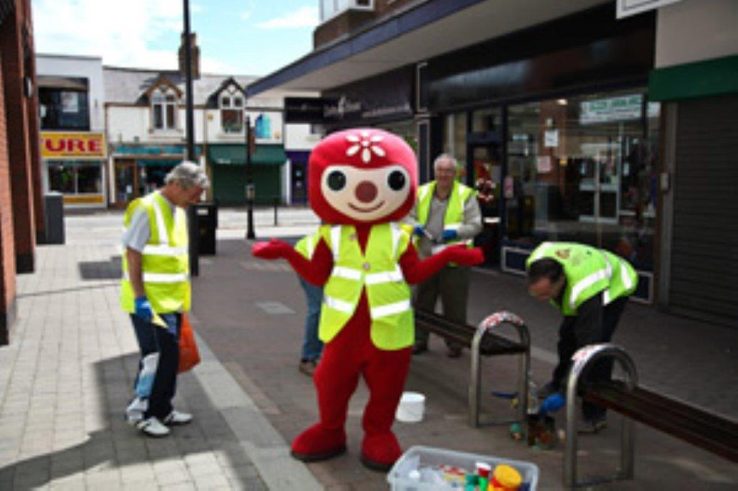

**Volunteers - Mold Spring Clean**

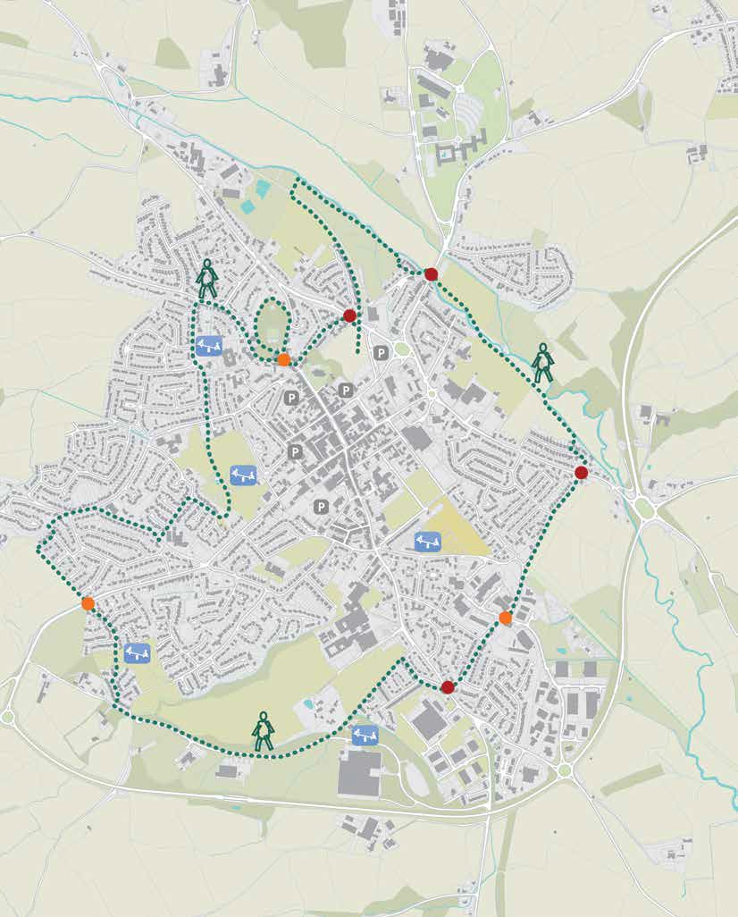

**Proposals for the Mold Green Band**

**Chapter Eight: A Competent Council**

Finally, these are changing times for Community & Town Councils. Mold faces many new challenges and opportunities. It is important that we are ready to face these challenges: to be Fit for the Future.

A number of ‘competency’ tests are emerging to help Community Councils determine how well equipped they are to meet the challenges ahead. These tests will bring more consistency to the sector, with higher standards of governance and financial management.

These tests might include:

* a democracy test: - Councillors must be elected at either an ordinary election or a by-election;
* a capability test: - the Community Council must employ a clerk with relevant professional qualifications, such as the Certificate in Local Council Administration (CiLCA).
* a capacity test: - the Council has a minimum annual budget of £200,000; and
* a governance test - the Council has sound financial management and internal control systems. It should also meet other criteria such as having a website on which it publishes agendas, minutes and accounts and is contactable by email.
* The Town Council is also subject to both internal and external audit

The Town Council undertook an audit during the year, to see how it faired against these tests. Here are our findings:

* All councillors have been declared elected. None have been co-opted.
* The Clerk has submitted her CiLCA portfolio and is awaiting the results.
* The town’s annual budget is over £200,000
* The Town Council has sound management and financial systems. Its accounts are scrutinised by others. Agendas, minutes, accounts and contact details can be viewed at [www.moldtowncouncil.org.uk](http://www.moldtowncouncil.org.uk). The Community can e-mail the Clerk to the Council at [townclerk@moldtowncouncil.org.uk](mailto:townclerk@moldtowncouncil.org.uk). A Charter is in place to govern our relationship with Flintshire County Council.

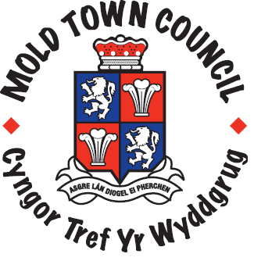**Contact Information**

Mold Town Council

Town Hall  
Earl Road

Mold

Flintshire

CH7 1AB

Telephone: 01352 758532 [www.moldtowncouncil.org.uk](http://www.moldtowncouncil.org.uk)

**Clerk and Finance Officer:** Samantha Roberts  
Telephone: 01352 758532 Email: [townclerk@moldtowncouncil.org.uk](mailto:townclerk@moldtowncouncil.org.uk)

**Support Officer:** Jane Evans  
Telephone: 01352 758532 Email: [supportofficer@moldtowncouncil.org.uk](mailto:supportofficer@moldtowncouncil.org.uk)  
  
**Town Manager:** Dave Hill  
Telephone: 01352 751819 Email: [tcm@moldtowncouncil.org.uk](mailto:towncentremanager@moldtowncouncil.org.uk)

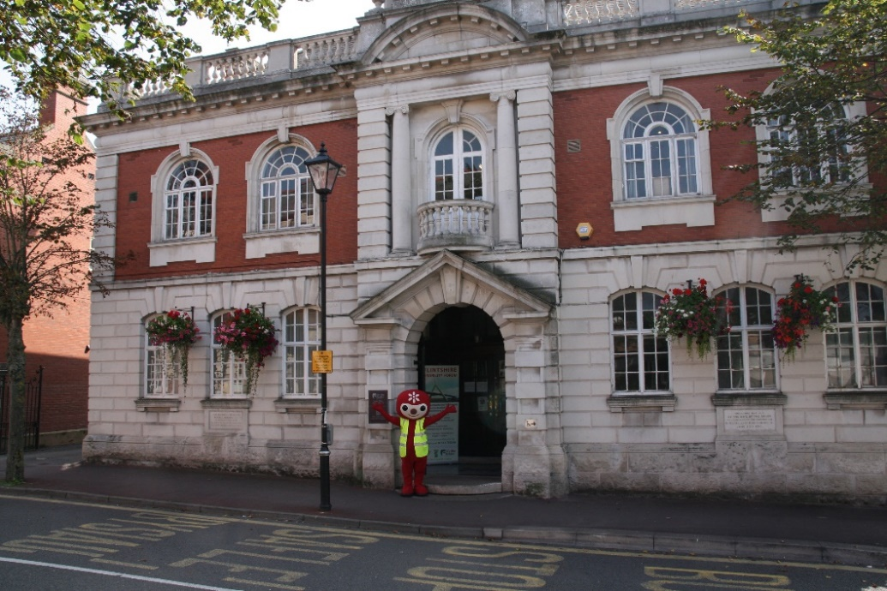**Cemetery Superintendent:**  
Arfon Williams-Cooke  
**Cemetery Assistant:**  
Michael Gallagher  
**Address:**  
The Lodge, Mold Cemetery, Alexandra Road, Mold, Flintshire CH7 1HJTelephone: 01352 753820

|  |  |  |  |
| --- | --- | --- | --- |
| **BRONCOED WARD** | |  |  |
| Haydn Bateman | Cortonwood, Blackbrook Road, Sychdyn. CH7 6LT | 01352 754510 / 07714 155446 | [haydn.bateman@yahoo.co.uk](mailto:haydn.bateman@yahoo.co.uk)  haydn.bateman@flintshire.gov.uk |
| Ray Dodd | Coleshill, Clayton Road, Mold.CH7 1SX | 01352 759715 | [raydodd@ouvip.com](mailto:raydodd@ouvip.com) |
| Gareth Williams | Glan-yr-Afon House, Brook Street, Mold. CH7 1PH | 01352 754442 / 07917 054135 | garethwilliams300@gmail.com |
| Carol Heycocks | 14 Bromfield Lane, Mold. CH7 1JL | 01352 754617 | carol.heycocks@gmail.com |
| **EAST WARD** | |  |  |
| Chris Bithell | The Coppins, 88 Hendy Road, Mold.CH7 1QR | 01352 754578 | [robert.c.bithell@talk21.com](mailto:robert.c.bithell@talk21.com)  [christopher.bithell@flintshire.gov.uk](mailto:christopher.bithell@flintshire.gov.uk) k.powell@flintshire.gov.uk |
| Richard Brookes | 4 Marlow Terrace, Mold. CH7 1HH | 01352 756252 | rjbrookes1975@aol.co.uk |
| Bryan Grew | 7 Maes yr Haul, Mold. CH7 1NS | 01352 759673 / 07547 446118 | [bgrew@sky.com](mailto:bgrew@sky.com) |
| Andrea Mearns | Rosscote, Gwernaffield Road CH7 1RE | 01352 757687 /  0752 3097900 | mearns@tiscali.co.uk |
| **SOUTH WARD** | |  |  |
| Geoff Collett | 8 Ffordd Hengoed, Mold. CH7 1QD | 01352 756582  07917 054138 | [geoffcollett2004@yahoo.co.uk](mailto:geoffcollett2004@yahoo.co.uk) |
| Anthony Parry | Brynwood, Bryn Coch Lane, CH7 1PS | 01352 754423  07710 360717 | [info@doddsauctioneers.co.uk](mailto:info@doddsauctioneers.co.uk) |
| Robin Guest | 36 Ffordd Pentre, Mold. CH7 1UY | 01352 757408  07812 016917 | [tobyreggie@hotmail.com](mailto:tobyreggie@hotmail.com)  robinguest@keeneandkelly.com |
| Philip Thomas | 10 Ffordd Hengoed, Mold CH7 1QD | 01352 753847  07932 345847 | pw.thomas10@gmail.com |
| **WEST WARD** |  |  |  |
| Brian Lloyd | Pwll Glas Farm Cottage, Gwernaffield Road, Mold CH7 1RQ | 01352 753107  07734 579898 | rbl.pwllglas@yahoo.co.uk |
| Bob Gaffey | 55 Dreflan, Mold. CH7 1DF | 01352 751886 | gaffeybobby@aol.com |
| Geoff Matthias | 7 Dreflan, Mold. CH7 1DE | 01352 753481  07515 297833 | geoffmatthias@hotmail.com |
| Karen Hodgkinson | 4 Elm Drive, Mold, CH7 1SG | 01352 751795 | theclubhouse@live.co.uk |

Mold Town Councillors 2015/16 Appendix 1.

Full Council and Committee meetings 2015/16 Appendix 2.

Full Council

|  |  |  |  |  |  |  |  |  |  |  |  |
| --- | --- | --- | --- | --- | --- | --- | --- | --- | --- | --- | --- |
| **2015/16** | | | | | | | | | | | |
| May | Jun | Jul | Aug | Sep | Oct | Nov | Dec | Jan | Feb | Mar | Apr |
| [13th](http://www.moldtowncouncil.org.uk/Mold-TC/UserFiles/Files/Main%20Council%20Minutes/Agm%20Min%20150513.doc)*  [27th](http://www.moldtowncouncil.org.uk/Mold-TC/UserFiles/Files/Main%20Council%20Minutes/MTC%20Min%20150527.docx) | [1st**](http://www.moldtowncouncil.org.uk/Mold-TC/UserFiles/Files/Main%20Council%20Minutes/MTC%20Min%20150601%20SM.docx)  [24th](http://www.moldtowncouncil.org.uk/Mold-TC/UserFiles/Files/Agendas/MTC%20Min%20150624.docx) | [22nd](http://www.moldtowncouncil.org.uk/Mold-TC/UserFiles/Files/Main%20Council%20Minutes/MTC%20Min%20150722.docx) | - | [30th](http://www.moldtowncouncil.org.uk/Mold-TC/UserFiles/Files/Main%20Council%20Minutes/MTC%20Min%20150930.docx) | [21st](http://www.moldtowncouncil.org.uk/Mold-TC/UserFiles/Files/Main%20Council%20Minutes/MTC%20Min%20141022.docx) | [25th](http://www.moldtowncouncil.org.uk/Mold-TC/UserFiles/Files/Main%20Council%20Minutes/MTC%20Min%20151125.docx) | [-](http://www.moldtowncouncil.org.uk/Mold-TC/UserFiles/Files/MTC%20Min%20141209%20SM.docx) | [27th](http://www.moldtowncouncil.org.uk/Mold-TC/UserFiles/Files/MTC%20Min%20160127.docx) | [24th](http://www.moldtowncouncil.org.uk/Mold-TC/UserFiles/Files/Main%20Council%20Minutes/MTC%20Min%20160224.docx) | [23rd](http://www.moldtowncouncil.org.uk/Mold-TC/UserFiles/Files/Main%20Council%20Minutes/MTC%20Min%20160323.docx) | [27th](http://www.moldtowncouncil.org.uk/Mold-TC/UserFiles/Files/Main%20Council%20Minutes/MTC%20Min%20160427.docx) |

 *Denotes the AGM. **Denotes a Special Meeting.

Personnel Committee

|  |  |  |  |  |  |  |  |  |  |  |  |
| --- | --- | --- | --- | --- | --- | --- | --- | --- | --- | --- | --- |
| **2015/16** | | | | | | | | | | | |
| May | Jun | Jul | Aug | Sep | Oct | Nov | Dec | Jan | Feb | Mar | Apr |
| - | - | - | - | [23rd](http://www.moldtowncouncil.org.uk/Mold-TC/UserFiles/Files/Personnel%20Minutes/Personnel%20Minutes%20150923.doc) | - | [9th](http://www.moldtowncouncil.org.uk/Mold-TC/UserFiles/Files/Personnel%20Minutes/Personnel%20Minutes%20151109.doc) | [-](http://www.moldtowncouncil.org.uk/Mold-TC/UserFiles/Files/Personnel%20Minutes/Personnel%20Minutes%20141209.doc) | - | - | [8th](http://www.moldtowncouncil.org.uk/Mold-TC/UserFiles/Files/Personnel%20Minutes/Personnel%20Minutes%20160308.doc) | - |

Policy & Audit Committee

|  |  |  |  |  |  |  |  |  |  |  |  |
| --- | --- | --- | --- | --- | --- | --- | --- | --- | --- | --- | --- |
| **2015/16** | | | | | | | | | | | |
| May | Jun | Jul | Aug | Sep | Oct | Nov | Dec | Jan | Feb | Mar | Apr |
| [18th](http://www.moldtowncouncil.org.uk/Mold-TC/UserFiles/Files/Audit%20Minutes/AuditSubMinutes%20150518.doc) | - | [20th](http://www.moldtowncouncil.org.uk/Mold-TC/UserFiles/Files/Audit%20Minutes/PolicyAuditMinutes%20150720.doc) | - | - | - | [16th](http://www.moldtowncouncil.org.uk/Mold-TC/UserFiles/Files/Audit%20Minutes/PolicyAuditMinutes%20151116.doc) | - | [11th](http://www.moldtowncouncil.org.uk/Mold-TC/UserFiles/Files/Audit%20Minutes/PolicyAuditMinutes%20160111.doc) | - | [21st](http://www.moldtowncouncil.org.uk/Mold-TC/UserFiles/Files/Audit%20Minutes/PolicyAuditMinutes%20160321.doc) | - |

Planning Committee

|  |  |  |  |  |  |  |  |  |  |  |  |
| --- | --- | --- | --- | --- | --- | --- | --- | --- | --- | --- | --- |
| **2015/16** | | | | | | | | | | | |
| May | Jun | Jul | Aug | Sep | Oct | Nov | Dec | Jan | Feb | Mar | Apr |
| [6th](http://www.moldtowncouncil.org.uk/Mold-TC/UserFiles/Files/Planning%20Minutes/Planning%20Minutes%20150506.doc) | [3rd](http://www.moldtowncouncil.org.uk/Mold-TC/UserFiles/Files/Planning%20Minutes/Planning%20Minutes%20150603.doc)  [29th](http://www.moldtowncouncil.org.uk/Mold-TC/UserFiles/Files/Planning%20Minutes/Planning%20Minutes%20150629.doc) |  |  | [2nd](http://www.moldtowncouncil.org.uk/Mold-TC/UserFiles/Files/Planning%20Minutes/Planning%20Minutes%20150902.doc) | [7th](http://www.moldtowncouncil.org.uk/Mold-TC/UserFiles/Files/Planning%20Minutes/Planning%20Minutes%20151007.doc) | [23rd](http://www.moldtowncouncil.org.uk/Mold-TC/UserFiles/Files/Planning%20Minutes/Planning%20Minutes%20151123.doc) | - | [25th](http://www.moldtowncouncil.org.uk/Mold-TC/UserFiles/Files/Planning%20Minutes/Planning%20Minutes%20160125.doc) | [3rd](http://www.moldtowncouncil.org.uk/Mold-TC/UserFiles/Files/Planning%20Minutes/Planning%20Minutes%20160203.doc) | [7th](http://www.moldtowncouncil.org.uk/Mold-TC/UserFiles/Files/Planning%20Minutes/Planning%20Minutes%20160307.doc)  [29th](http://www.moldtowncouncil.org.uk/Mold-TC/UserFiles/Files/Planning%20Minutes/Planning%20Minutes%20160329.doc) | [6th](http://www.moldtowncouncil.org.uk/Mold-TC/UserFiles/Files/Planning%20Minutes/Planning%20Minutes%20160406.doc)  [25th](http://www.moldtowncouncil.org.uk/Mold-TC/UserFiles/Files/Planning%20Minutes%20160425.doc) |

Cemetery Committee

|  |  |  |  |  |  |  |  |  |  |  |  |
| --- | --- | --- | --- | --- | --- | --- | --- | --- | --- | --- | --- |
| **2015/16** | | | | | | | | | | | |
| May | Jun | Jul | Aug | Sep | Oct | Nov | Dec | Jan | Feb | Mar | Apr |
| - | - | [15th](http://www.moldtowncouncil.org.uk/Mold-TC/UserFiles/Files/Cemetery/Cemetery%20Minutes%20150715.doc) | - | - | - | [2nd](http://www.moldtowncouncil.org.uk/Mold-TC/UserFiles/Files/Cemetery/Cemetery%20Minutes%20151102.doc) | - | - | - | - | - |

Community Development & Regeneration Committee

|  |  |  |  |  |  |  |  |  |  |  |  |
| --- | --- | --- | --- | --- | --- | --- | --- | --- | --- | --- | --- |
| **Minutes for 2015/16** | | | | | | | | | | | |
| May | Jun | Jul | Aug | Sep | Oct | Nov | Dec | Jan | Feb | Mar | Apr |
| - | - | - | - | [16th](http://www.moldtowncouncil.org.uk/Mold-TC/UserFiles/Files/Tourism%20Minutes/CDR%20Minutes%20150916.docx) | - | - | - | - | - | [9th](http://www.moldtowncouncil.org.uk/Mold-TC/UserFiles/Files/Tourism%20Minutes/CDR%20Minutes%20160309.docx) | - |