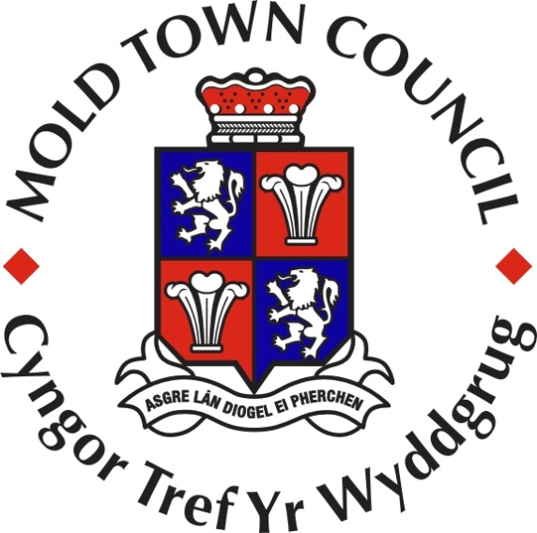
MOLD TOWN COUNCIL
BIODIVERSITY AND ECOSYSTEM RESILIENCE REPORT 2022 to 2025
(Environment (Wales) Act 2016 – Section 6 Duty)

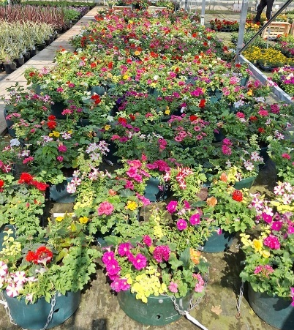
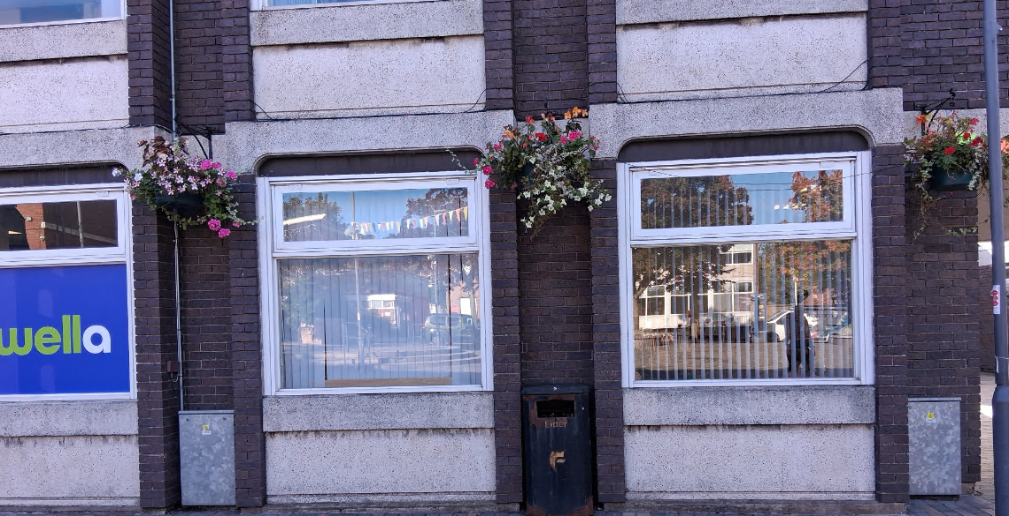
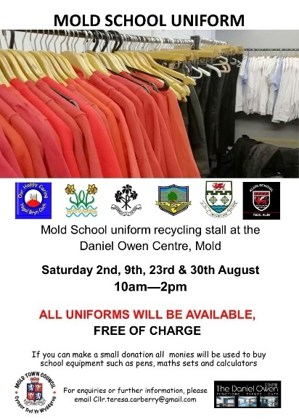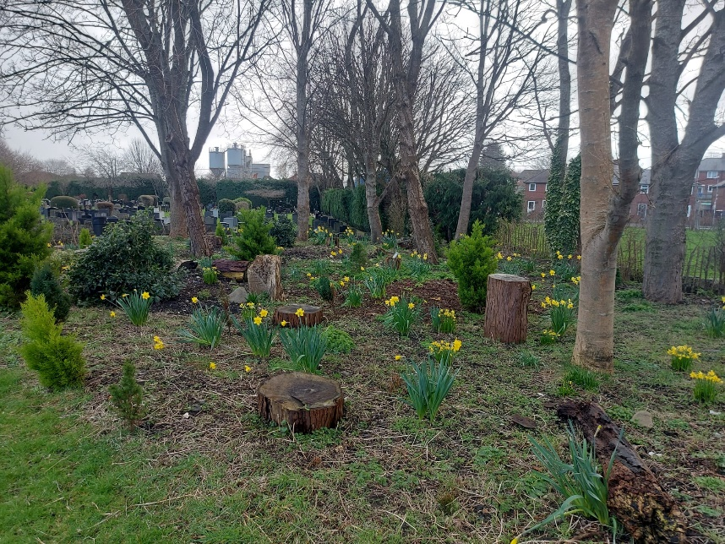

Introduction
The Environment (Wales) Act 2016 places a legal duty on public bodies, including Town and Community Councils, to maintain and enhance biodiversity and promote ecosystem resilience. This report outlines the actions Mold Town Council has taken during the 2022 to 2025 period, progress against its Biodiversity Action Plan (BAP), and future commitments.
Mold is a historic market town located within Flintshire and adjacent to the Clwydian Range and Dee Valley Area of Outstanding Natural Beauty (AONB). Its position, landscape features, green spaces, and long-established cultural assets create an important mosaic of habitats and community connections with the natural environment.
Mold Town Council recognises the importance of biodiversity to the wellbeing, sustainability and resilience of the town. The Council continues to embed environmental considerations across its services, community partnerships and long-term planning. This report aligns with:
- Mold Town Council Biodiversity Action Plan
- Mold Town Council Biodiversity and Environmental Policy
- Well-being of Future Generations (Wales) Act 2015 – A Resilient Wales, A Globally Responsible Wales
- Flintshire County Council climate and nature strategies.

Overview of Council Functions Influencing Biodiversity
Mold Town Council delivers a wide range of services, activities, and community initiatives that contribute to the wellbeing of residents and visitors. Through its statutory responsibilities, operational management, and strategic partnerships, the Council plays a significant role in shaping the town’s natural environment and has the ability to positively influence local and regional decision-making.

In addition to its direct functions, the Council works closely with Flintshire County Council, local volunteer groups, heritage organisations, and community partners. These relationships enable the Council to support, guide, and advocate for actions that protect biodiversity, enhance green spaces, and build ecological resilience across Mold.

The Council’s activities that directly or indirectly impact biodiversity include:
Cemetery & Burial Grounds
- Management of green spaces with opportunities for wildflower development and habitat creation.
- Retention of deadwood and natural materials to support ecological networks.
Town Centre Planting & Gateway Signage
- Provision of pollinator-friendly hanging baskets, tubs, and signage planters.
Bailey Hill
- Management of a scheduled ancient monument and public green space.
- Ongoing maintenance of the living roof at the Bailey Hill Centre.
Community Grants & Partnerships
- Financial support for local environmental groups and biodiversity projects.
- Collaboration with the Mold Cittaslow Working Group and Mold Plastic Reduction Steering Group.
Events & Community Engagement
- Support for the Mold Spring Clean and other community-led environmental initiatives.
- Educational and promotional activities involving Mold Town Youth Council.
Planning Consultation
- Providing local input on planning applications with biodiversity as a key consideration.

PROGRESS AGAINST THE BIODIVESITY ACTION PLAN (2022 TO 2025)
OBJECTIVE 1
Biodiversity Objectives | Action | Monitored by
Embed biodiversity into decision making & procurement | - When discussing planning applications, effects on biodiversity is also considered when providing responses.  - Embed biodiversity as a standard agenda item within one of Mold Town Council’s Committees to ensure ongoing oversight, discussion, and integration of biodiversity considerations into decision-making processes.  - Invite officers of Flintshire County Council, Climate Change Team to introduce Climate Change Toolkit for Town and Community Councils to Members. | Chair of Planning Committee  Town Clerk  Town Clerk
Progress:
The Chair of the Planning Committee routinely reminds Members to consider potential impacts on biodiversity and the environment when discussing planning applications. This practice has become standard and is fully embedded in the Committee’s operations. It will continue to be a key focus going forward to ensure environmentally informed responses.

Biodiversity has now been embedded as a standing agenda item on both the Community, Development and Regeneration Committee and the Cemetery Committee. This ensures that biodiversity and environmental considerations are consistently addressed when reviewing projects, updates to services, or other relevant matters.

While officers from Flintshire County Council’s Climate Change Team have not yet been invited to a Full Town Council meeting, this action will be carried forward into the 2025–2028 Action Plan to provide Members with guidance and practical support in integrating climate and biodiversity objectives into Council activities.

Raise awareness of biodiversity & its importance | - Utilise the Town Council’s communication channels, including social media, to regularly share information on biodiversity, its local relevance, and the Council’s related initiatives to raise public awareness and encourage community involvement.  - Develop a dedicated biodiversity page on the Town Council’s website to provide accessible information, resources, and links to relevant organisations and initiatives, supporting transparency and public engagement with the Council’s environmental responsibilities.  - Include Climate Change as an agenda item for discussion at Mold Town Youth Council Meeting. | Town Clerk  Town Clerk  Town Clerk
Progress:
The Town Council regularly uses its social media channels to share updates on local environmental projects, biodiversity initiatives, and available funding streams. This ongoing communication raises public awareness and encourages community participation. This action will continue to be a priority going forward.

A dedicated biodiversity page has been developed on the Town Council’s website, providing information, resources, and links to relevant organisations and initiatives. This page will be further enhanced and expanded once the new Mold Town Council website is completed, improving accessibility and transparency.

Climate change and biodiversity have been included as agenda items at multiple Mold Town Youth Council meetings. The Council has also hosted a guest speaker from Flintshire County Council’s Climate Change Team, providing participants with expert guidance and insight. These discussions form an important part of ongoing youth engagement in environmental issues.

OBJECTIVE 2
Biodiversity Objectives | Action | Monitored by
Safeguard principle species and habitats | - Develop and agree a Tree Policy for the trees in Mold Cemetery.  - Promote species recording – Bird Watch – Bailey Hill Facebook. Fauna and Flora posts. | Town Clerk  Town Clerk
Progress:
A comprehensive Tree Policy has been developed and implemented for the trees in Mold Cemetery. The policy aligns with Flintshire County Council’s Environmental Policy and provides guidance for the management, maintenance, and protection of the Cemetery’s tree stock, ensuring the continued provision of habitat and ecological value.

The Council continues to promote species recording and community engagement with local wildlife. Updates on birds, fauna, and flora are regularly shared via the Bailey Hill Facebook page, supporting awareness, knowledge-sharing, and active participation in biodiversity monitoring within the town.

OBJECTIVE 3
Biodiversity Objectives | Action | Monitored by
Restore & create habitats and resilient ecological networks | - The Council will choose pollinator plants and flowers for the summer hanging baskets and planters located on the Gateway signage.  - Wildflower areas will be created in areas of Mold Cemetery that is not used for burials. Plants discarded by visitors at the cemetery will be recycled and planted in the Wildflower areas.  - Trees felled or fallen in Mold Cemetery will remain on site to create natural habitats.  - Annual maintenance of the Bailey Hill Centre ‘living roof’. | Community & Engagement Officer  Cemetery Superintendent  Cemetery Superintendent  Admin Support Officer – Bailey Hill
Progress:
The Council has continued to select and plant pollinator-friendly flowers and plants in the summer hanging baskets and planters located on the town’s Gateway signage. These plantings support pollinator species, enhance biodiversity in public areas, and contribute to the town’s visual appeal. This action will remain ongoing and is planned to continue annually as a key part of the Council’s biodiversity initiatives.

Wildflower zones have been established in areas of the Cemetery that are not used for burials. Plants discarded by visitors continue to be recycled and incorporated into these wildflower areas, creating additional habitats and promoting sustainable management practices.

Trees that have been felled or have fallen naturally within Mold Cemetery are left on site, where it is safe to do so and in line with health and safety procedures. This practice provides natural habitats for insects, fungi, and small wildlife, supporting ecological networks and enhancing biodiversity within the Cemetery.

Annual maintenance of the living roof at Bailey Hill Centre is ongoing, ensuring that it continues to provide a habitat for pollinators and contributes to urban greening initiatives across the town.

OBJECTIVE 4
Biodiversity Objectives | Action | Monitored by
Tackle negative factors: for e.g. reduce pollution, use nature-based solutions, address invasive species. | - Assess energy contracts for all Mold Town Council premises and at the point of renewal, seek to procure energy from suppliers with a demonstrably greener and more sustainable energy mix, prioritising 100% renewable sources where feasible.  - Review one use plastic policy for community events and consideration made Review and strengthen the Town Council’s single-use plastics policy for community events, ensuring that environmental criteria are considered when engaging external businesses and suppliers, with a preference for those demonstrating sustainable and low-waste practices. | Town Clerk  Events and Community Engagement Officer
Progress:
During the office move in April 2025, the Council actively considered the environmental impact of a range of energy suppliers when selecting new providers for its premises. This assessment included evaluating suppliers’ energy mixes and prioritising greener, more sustainable options. Going forward, the environmental impact of suppliers will remain a key factor whenever energy contracts are renewed or re-tendered, ensuring this continues as an active action point.

A review and strengthening of the Council’s single-use plastics policy for community events was not completed within the current action plan timeframe. However, this action will carry forward into the next action plan cycle, with the aim of finalising the policy by the end of that period. The updated policy will ensure that environmental criteria are considered when engaging external businesses and suppliers, with a preference for those demonstrating sustainable and low-waste practices.

OBJECTIVE 5
Biodiversity Objectives | Action | Monitored by
Use, improve, and share experience | - Continue to lead and support the Mold Cittaslow Working Group, ensuring that biodiversity and environmental sustainability remain integral to its projects and community initiatives.  - Utilise the Council’s social media platforms to disseminate information on Council services, community initiatives, and environmental priorities, ensuring consistent and accessible communication with residents. | Town Clerk  Events and Community Engagement Officer
Progress:
The Council continues to actively lead and support the Mold Cittaslow Working Group, ensuring that biodiversity and environmental sustainability are central to its projects and community initiatives. Two Councillors are actively engaged in supporting the Cittaslow regime, while the Town Clerk serves as Treasurer for Cittaslow UK, providing governance and oversight for both local and national activities.

The Council continues to utilise its social media platforms to share information on Council services, environmental priorities, and community initiatives. These channels ensure consistent, accessible communication with residents and encourage public participation in sustainability and biodiversity projects.

OBJECTIVE 6
Biodiversity Objectives | Action | Monitored by
Support capacity and/ or other organisations | - Appoint a Mold Town Council representative to attend Mold Plastic Reduction Steering Group meetings and ensure regular reporting of key outcomes and recommendations to Full Council for consideration and action.  - Promote and administer a Community Grants scheme to support local groups and organisations, including those delivering projects that enhance biodiversity, sustainability, and community wellbeing. | Town Clerk  Town Clerk
Progress:
A Council representative has been appointed to attend Mold Plastic Reduction Steering Group meetings. This representative actively participates in discussions, supports local environmental events.

The Council continues to promote and administer its Community Grants scheme, providing support to local groups and organisations. Priority is given to projects that enhance biodiversity, sustainability, and overall community wellbeing, helping to strengthen the town’s environmental and social resilience.

NEW AND EMERGING WORKSTREAMS (2025-2028)
Climate Change & Toolkit Integration
The Council plans to integrate the Climate Change Toolkit for Town and Community Councils into its strategic work. This will strengthen alignment with county-wide environmental priorities, support informed decision-making and help embed climate resiliance and biodiversity considerations across Council activities including Cemetery management and maintenance.
Youth Engagement
The Mold Youth Council will continue to exapnd its involvement in biodiversity and environmental projects, fostering awareness and encouraging active youth participation in environmental stewardship.
Bailey Hill and Cemetery Development
The Council is exploring additional biodiversity enhancements as part of ongoing site management at Bailey Hill and Mold Cemetery. Opportunities are being considered to collaborate with heritage bodies, conservation groups and locla volunteers to improve habitats, wildlife corridors and ecological networks within these historically and environmentally significant areas.
Community Grant
The Council will continue to promote its Community Grants scheme, prioritising projects that enhance biodiversity and sustainability. Increased outreach and encouragement of applications from environmental groups aim to maximise both ecological and community benefits. The Council will also actively seek additional funding opportunities to support initiatives directly impacting Mold Cemetery and other Council-managed green spaces.
Partnership Working and Community Engagament
The Council will strengthen partnerships with One Voice Wales – Biodiversity Team and the Flintshire County Council Biodiversity Officer to share expertise, develop joint initiatives, and promote community engagement in local biodiversity projects. These partnerships aim to enhance knowledge exchange, support citizen science, and encourage wider public participation in environmental stewardship across Mold.

REVIEW OF COUNCIL POLICIES AND PRACTICES
The Council continues to follow and reference its Biodiversity and Environmental Policy, which sets out principles for:
- Sustainable procurement
- Environmental responsibility in event delivery
- Waste minimisation
- Protection of habitats and species
All reviewed and new policies will ensure that, where possible, biodiversity considerations are integrated into decision making and operational practices. Future reviews will further strengthen the alignment of policies with the Biodiversity Action Plan (BAP) and the Council’s Well-being objectives, ensuring a consistent and proactive approach to supporting local ecosystems and sustainability initiatives.
CHALLENGES
Mold Town Council recognises several ongoing challenges in implementing its biodiversity and environmental objectives:
- Resource and Staffing Constraints: The Council has a limited number of staff and officers responsible for environmental management, meaning that time-intensive projects, species monitoring and habitat enhancement initiatives must be carefully considered. Expanding biodiversity activities may require additional staff time or external support.
- Financial Limitations: While the Council supports biodiversity through grants, planting, and community initiatives, funding is finite. Balancing budgetary constraints with the costs of habitat creation, maintenance, and specialist services (e.g., ecological surveys or living roof maintenance) remains an ongoing challenge.
- Training and Member Development: Continued training and guidance for Members and staff are required to ensure informed decision-making on planning consultations, procurement, and project delivery that impacts biodiversity. Keeping knowledge current on legislation, best practice, and emerging environmental initiatives is essential.
CONCLUSION
Mold Town Council continues to make steady progress in meeting its duties under the Environment (Wales) Act 2016. The Council remains committed to enhancing biodiversity, supporting resilient ecosystems, and embedding environmental responsibility across all services. With strong community partnerships, active public engagement, and clear future priorities, the Council is well placed to continue contributing positively to local nature recovery and environmental wellbeing.

