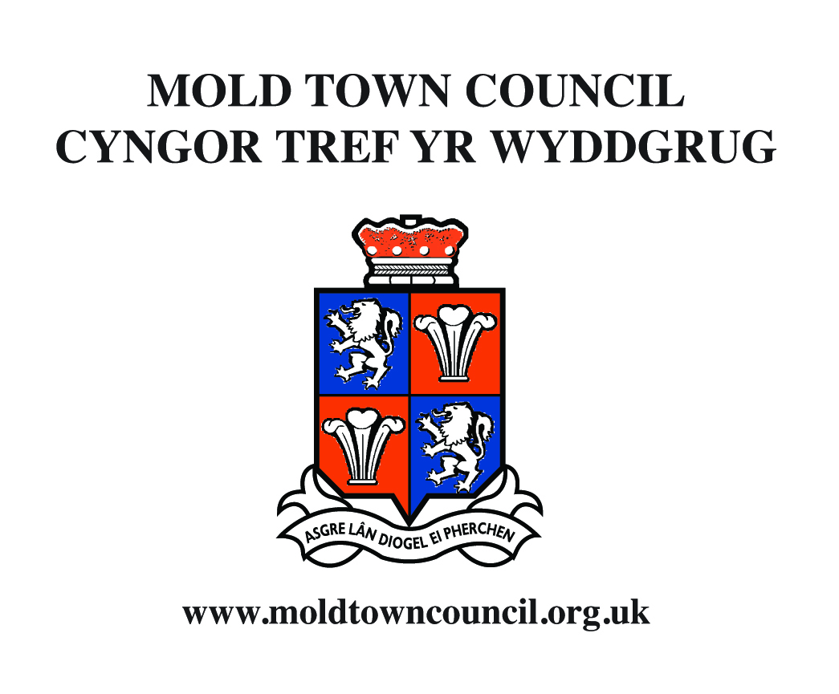
Application for Financial Assistance

Who is eligible?

- Local voluntary or charitable groups based and/or working in Mold; and
- Regional or national charitable groups that undertake work in Mold or provide assistance to residents of the Town.
- Where a voluntary or charitable group generate surplus to donate to 3rd parties they may not be eligible for financial assistance from Mold Town Council.
- The work of the group should benefit some or all of the residents of Mold.

What can grants be used for?

- The capital costs, or a contribution towards the costs of, any new or replacement equipment that may be required to assist the group in its activities;
- The costs, or a contribution towards the costs involved in the presentation of an event, concert, performance or specific activity produced by a local group;
- The costs involved in the establishment of a new local voluntary or charitable group; or
- The general running costs – for up to a period of three years – incurred by local voluntary and charitable groups to enable them to sustain their services and activities.

Who makes the decision and when are grants given?

- Applications are considered by a small group of Town Council Members to ensure that they meet the criteria for assistance. The final decision on the awarding of a grant to any group will be made by the Town Council.
- Grants are awarded at the Town Council meetings in January and June.
- Applications for general running costs will only be considered once each year at the January meeting.

Mold Town Council Cyngor Tref yr Wyddgrug

Helen Belton Neuadd y Dref, Ffordd yr Iarll Town Hall, Earl Road
Clerk and Finance Officer Yr Wyddgrug CH7 1AB Mold, CH7 1AB
Clerc a Swyddog Cyllid Ffôn 01352 758532 Tel. 01352 758532
Ffacs 01352 755804 Fax 01352 755804
townclerk@moldtowncouncil.org.uk townclerk@moldtowncouncil.org.uk
www.moldtowncouncil.org.uk www.moldtowncouncil.org.uk

Application for Financial Assistance

Please complete the following:

Full name of organisation

Name and address of Secretary

______________________________________________________________________________________________

Name and address of Treasurer

1. Where does your organisation meet and how often are meetings held?

______________________________________________________________________________________________

______________________________________________________________________________________________

2. How many people from Mold are members of your organisation? ___________________________________

3. What is the approximate age group of members? ___________________________________

4. What type of activities are performed by your organisation?

_____________________________________________________________________________________________

_____________________________________________________________________________________________

_____________________________________________________________________________________________

_____________________________________________________________________________________________

_____________________________________________________________________________________________

5. For what purposes would a grant be needed?

_____________________________________________________________________________________________

_____________________________________________________________________________________________

_____________________________________________________________________________________________

_____________________________________________________________________________________________

_____________________________________________________________________________________________

6. What fund-raising activities took place in the last 12 months and how much was raised?

_____________________________________________________________________________________________

_____________________________________________________________________________________________

_____________________________________________________________________________________________

7. What fund-raising activities are proposed in the next 12 months?

_____________________________________________________________________________________________

_____________________________________________________________________________________________

_____________________________________________________________________________________________

8. Please state the amounts and details of anticipated income in the next 12 months (subscriptions etc)

_____________________________________________________________________________________________

_____________________________________________________________________________________________

_____________________________________________________________________________________________

9. Please state the amounts and details of anticipated expenditure in the next 12 months

_____________________________________________________________________________________________

_____________________________________________________________________________________________

_____________________________________________________________________________________________

10. Please state whether your group/organisation made a charitable donation the previous year to another organization. If yes, please state the value and to whom.

_____________________________________________________________________________________________

_____________________________________________________________________________________________

_____________________________________________________________________________________________
10b. Please state whether your group/organization intend on donating to another organization in the current year.

_____________________________________________________________________________________________

_____________________________________________________________________________________________

Application for Financial Assistance

Please complete the following:

11. Please outline any other details that you would wish the Town Council to take into account when considering this application

Please enclose with this application:

a) Your organisations most recent statement of account; and
b) An up to date bank statement

Declaration:

I / we declare that the foregoing particulars are correct and that any grant received will be applied for the sole benefit of my / our organisation

Signed:

Secretary / Treasurer Date

_________________________________________________ ___________________________

Completed application forms should be returned to Helen Belton, Clerk and Finance Officer,
Mold Town Council, Town Hall, Earl Road, Mold CH7 1AB

