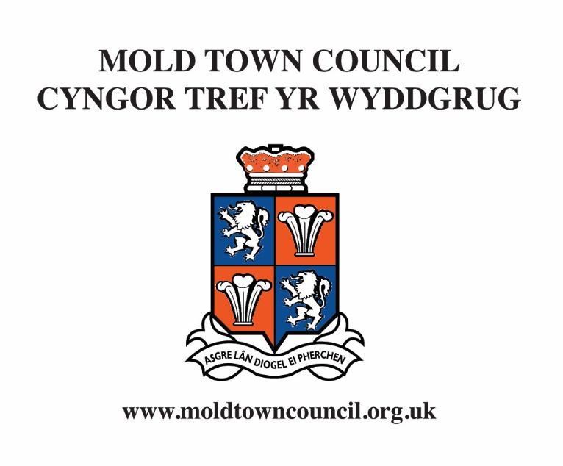
Application for Financial Assistance

Who is eligible?

- Local voluntary or charitable groups based and/or working in Mold; and
- Regional or national charitable groups that undertake work in Mold or provide assistance to residents of the Town.
- Where a voluntary or charitable group generate surplus to donate to 3rd parties they may not be eligible for financial assistance from Mold Town Council.
- The work of the group should benefit some or all of the residents of Mold.

What can grants be used for?

- The capital costs, or a contribution towards the costs of, any new or replacement equipment that may be required to assist the group in its activities;
- The costs, or a contribution towards the costs involved in the presentation of an event, concert, performance or specific activity produced by a local group;
- The costs involved in the establishment of a new local voluntary or charitable group; or
- The general running costs – for up to a period of three years – incurred by local voluntary and charitable groups to enable them to sustain their services and activities.

Who makes the decision and when are grants given?

- Applications are considered by a small group of Town Council Members to ensure that they meet the criteria for assistance. The final decision on the awarding of a grant to any group will be made by the Town Council.
- Grants are awarded at the Town Council meetings in January and June.
- Applications for general running costs will only be considered once each year at the January meeting.

Mold Town Council Cyngor Tref yr Wyddgrug

Samantha Roberts Neuadd y Dref, Ffordd yr Iarll Town Hall, Earl Road
Clerk and Finance Officer Yr Wyddgrug CH7 1AB Mold, CH7 1AB
Clerc a Swyddog Cyllid Ffôn 01352 758532 Tel. 01352 758532
Ffacs 01352 755804 Fax 01352 755804
townclerk@moldtowncouncil.org.uk townclerk@moldtowncouncil.org.uk
www.moldtowncouncil.org.uk www.moldtowncouncil.org.uk

Application for Financial Assistance

Please complete the following:

Full name of organisation

Name and address of Secretary

______________________________________________________________________________________________

Name and address of Treasurer

1. Where does your organisation meet and how often are meetings held?

______________________________________________________________________________________________

______________________________________________________________________________________________

2. How many people from Mold are members of your organisation? ___________________________________

3. What is the approximate age group of members? ___________________________________

4. What type of activities are performed by your organisation?

_____________________________________________________________________________________________

_____________________________________________________________________________________________

_____________________________________________________________________________________________

_____________________________________________________________________________________________

_____________________________________________________________________________________________

5. For what purposes would a grant be needed?

_____________________________________________________________________________________________

_____________________________________________________________________________________________

_____________________________________________________________________________________________

_____________________________________________________________________________________________

_____________________________________________________________________________________________

6. What fund-raising activities took place in the last 12 months and how much was raised?

_____________________________________________________________________________________________

_____________________________________________________________________________________________

_____________________________________________________________________________________________

7. What fund-raising activities are proposed in the next 12 months?

_____________________________________________________________________________________________

_____________________________________________________________________________________________

_____________________________________________________________________________________________

8. Please state the amounts and details of anticipated income in the next 12 months (subscriptions etc)

_____________________________________________________________________________________________

_____________________________________________________________________________________________

_____________________________________________________________________________________________

9. Please state the amounts and details of anticipated expenditure in the next 12 months

_____________________________________________________________________________________________

_____________________________________________________________________________________________

_____________________________________________________________________________________________

10. Please state whether your group/organisation made a charitable donation the previous year to another organization. If yes, please state the value and to whom.

_____________________________________________________________________________________________

_____________________________________________________________________________________________

_____________________________________________________________________________________________
10b. Please state whether your group/organization intend on donating to another organization in the current year.

_____________________________________________________________________________________________

_____________________________________________________________________________________________

Application for Financial Assistance

Please complete the following:

11. Please outline any other details that you would wish the Town Council to take into account when considering this application

Please enclose with this application:

a) Your organisations most recent statement of account; and
b) An up to date bank statement

Declaration:

I / we declare that the foregoing particulars are correct and that any grant received will be applied for the sole benefit of my / our organisation

Signed:

Secretary / Treasurer Date

_________________________________________________ ___________________________

Completed application forms should be returned to Samantha Roberts, Clerk and Finance Officer,
Mold Town Council, Town Hall, Earl Road, Mold CH7 1AB

Privacy Notice for Financial Assistance

Mold Town Council is the Data Controller under the new data protection law and will use the information you provide on this form in order to contact you about your grant application.

If you are an organisation or a group the legal basis for processing this data is the necessity for compliance with a legal obligation to consider your grant request.

If you include any personal details on this grant request on behalf of an organisation or group, the legal basis for processing this data is your consent to do so. You can withdraw your consent at any time by notifying us. Our contact details to do so, or for any other queries, are Mold Town Council, 1st Floor, Town Hall, Earl Road, Mold, Flintshire CH7 1A.

We will keep your data for six years if your grant application is successful and for six months if your application is turned down plus the current financial year, which runs from 1st April to 31st March. Your information will not be shared further.

Individuals have a number of rights under data protection law, including the right to request their information. You also have a right to make a complaint about our handling of your personal data to the Information Commissioner’s Office https://ico.org.uk/

Information you provide will only be used for the stated purpose. Further information about the processing of your data can be found on our website at www.leominstertowncouncil.gov.uk

You can contact the Town Council’s Data Protection Officer, Paul Russell, by post at 2 Church Road, Knighton, Powys LD7 1EB, by email at paul@micrshadevsm.co.uk, or by telephone on 07772 657446.

Please confirm your consent below. You can grant consent to any or all of the purposes listed. You can withdraw or change your consent at any time.

We may contact you to keep you informed about what is going on in the Council‘s area including news, events, meetings and activities. These communications may also sometimes appear on our website, or in printed or electronic form including social media.

We may use your name and photo in our newsletters, or on our website, or our Facebook page.

KEEPING IN TOUCH

Yes please, I would like to receive communications by email.

Yes please, I would like to receive communications by telephone.

Yes please, I would like to receive communications by mobile phone including text message.

Yes please, I would like to receive communications by social media including Facebook.

Yes please, I would like to receive communications by post.

