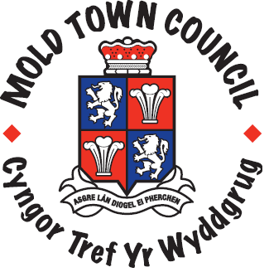
MOLD CEMETERY FEES – From 1st April 2025

Mold Non-Resident
Resident of Mold
Earth/Bricked Graves

Grave for one £1050.00 £2,100.00
First Interment Grave for 2 £1,470.00 £2,940.00
Each additional interment £762.00 £1,524.00
New Bricked Grave, first
Interment (materials not included) £1,649.00 £3,298.00
Each additional bricked interment £850.00 £1,700.00

**No charge for child burials**

Burial of casket after cremation

First interment – Plot for 2 £546.00 £1092.00
Each additional casket interment £210.00 £420.00

Right to erect headstone £159.00
Right to erect tablet £82.00
Additional inscription £39.00
Search fee £21.00
Saturday burial (subject to approval)
Additional charge £382.00 £764.00
Saturday ashes interment
Additional charge £100.00 £200.00

